|  |
| --- |
| Name: Mr. Ranul Pasan Ladduwahetty |
| Student Reference Number: 10673986 |



|  |  |  |
| --- | --- | --- |
| Module Code: PUSL2010 - 19/AU/M | Module Name: PUSL2010 Servers, Datacentres and Cloud (19/AU/M) | |
| Coursework Title: Coursework (PUSL2010/C1) | | |
| Deadline Date:  Sunday, 10 May 2020 | | Member of staff responsible for coursework:  Mr. Chamindra Attanayake |
| Programme: BSc (Hons) Software Engineering (4872) | | |
| Please note that University Academic Regulations are available under Rules and Regulations on the University website [www.plymouth.ac.uk/studenthandbook](http://www.plymouth.ac.uk/studenthandbook). | | |
| Group work: please list all names of all participants formally associated with this work and state whether the work was undertaken alone or as part of a team. Please note you may be required to identify individual responsibility for component parts.  Mr. Ranul Ladduwahetty  Mr. Hewa Hasanka  Mr. Wijesuriya Wijesuriya  Mr. Muhandiramlage Bandara  Mr. Kadupitige Chamarasinghe  ***We confirm that we have read and understood the Plymouth University regulations relating to Assessment Offences and that we are aware of the possible penalties for any breach of these regulations. We confirm that this is the independent work of the group.***  Signed on behalf of the group: Mr. Ranul Ladduwahetty | | |
| Individual assignment: ***I confirm that I have read and understood the Plymouth University regulations relating to Assessment Offences and that I am aware of the possible penalties for any breach of these regulations. I confirm that this is my own independent work.***  Signed : | | |
| Use of translation software: failure to declare that translation software or a similar writing aid has been used will be treated as an assessment offence.  I *have used/not used translation software.  If used, please state name of software………………………………………………………………… | | |
| **Overall mark _____% Assessors Initials ______ Date_________** | | |



**Servers, Datacentres and Cloud**

**PUSL2010 Coursework 2020**

**Coursework and Group Details**

Part A

As the head of IT operation, you are supposed to provide a detail proposal regarding the IT infrastructure, and you must convince the management to select a proper infrastructure deployment. Currently you have an option of going with traditional server deployment, virtualized deployment or cloud base (in private, public, community, or hybrid) and also in housed (on site) or offsite (ISP) based deployment. Your report must explore all the possible technologies indicating all positive and negative with the respective deployment models. The report must indicate one clear path giving precise details which will be easy to decide on the solution without any ambiguity. The proposal must address current operation future enhancements path for the organization. The proposal must give all technical details. Note: Your proposal must be different from the sample given on part B. (part B is one of a solution with virtualized platform)

Part B

Implement the core infrastructure servicers as given in the diagram using any virtual platform you prefer with respective security settings. You must indicate all the key steps with screen shots with correct justification for the steps. The group must be able to explain any implementation related steps, technologies which used for the solution. The group must maintain a meeting logbook and it needs to be presented during the group presentation.

Deliverables:

* Produce a report elaborating the design
* Possible technologies with pros and cons
* Clear made decision
* Future enhancements path
* Technical details
* Implementation of the core infrastructure
  + Steps shown as screenshots
  + Technologies used
* You should justify all your choices
* Report Length: Maximum limit 3500 words

Group No: 1

Group Name: TEAM RPLS

Members

|  |  |  |  |
| --- | --- | --- | --- |
| NSBM ID | Plymouth ID | Student Name | Degree Program |
| **10026394** | **10673986** | **Mr. R.P. Ladduwahetty (Team Head)** | **SE** |
| 10026404 | 10673969 | Mr.H.V.L. Hasanka (Deputy Head) | SE |
| 10022546 | 10673943 | Mr. K.M.R.P. CHAMARASINGHE | SE |
| 10012039 | 10673936 | Mr. M.I.C BANDARA | SE |
| 10022548 | 10674049 | Mr. W.A.D.N.N. WIJESURIYA | SE |

*SE: BSc (Hons) Software Engineering (4872)

Table of Contents

PART A 6

1. INTRODUCTION 6

1.1. Introduction 6

1.2. Objectives 6

1.3. Issues 6

2. ANALYSIS 2

3. TECHNOLOGY JUSTIFICATION 8

3.1. Cloud Services - 8

3.2. Traditional Server Deployment - 13

3.4. Virtualized deployment - 13

3.5. In-Housed Deployment – 14

3.6. Offsite Server Deployment – 15

4. DISCUSSION AND CONCLUSION 16

Mr. R.P. Ladduwahetty’s Solution 16

Mr. W.A.D.N.N. WIJESURIYA’s Solution 16

Mr. H.V.L. Hasanka’s Solution 16

Mr. M.I.C BANDARA’s Solution 18

GROUP SOLUTION 18

PART B 19

IMPLEMENTATION BRIEF 19

SCREENSHOTS (INFRASTRUCTURE SETUP AND IMPLEMENTATION) 22

Session (1/2) – Setup and Network Configuration 22

Session (2/2) – Infrastructure Implementation 28

MEETING LOGS 37

WORKLOAD 43

BIBLIOGRAPHY 44

REFERENCES 45

Table of Figures

*Figure 1: Illustration of trends for SaaS (AALPHA, 2020)* 2

*Figure 2: Illustration of Growth in Remote Work (flexjobs, 2020)* 3

*Figure 3: Illustration of the Food Management Network* 7

*Figure 4: Graph of Number of Internet User (Our World in Data, 2017)* 8

*Figure 5: Graph of Number of Internet User in the World (Our World in Data, 2017)* 9

*Figure 6:Comparison Illustration of Iaas, PaaS and SaaS (BigCommerce, 2020)* 10

*Figure* 7: Illustrations of the cloud computing services revenue for the current period. (Ranger, 2020) 12

*Figure* 7*: Extraction of VM Images* 21

*Figure* 8*: Booting from firmware for ESXi Installation on host* 21

*Figure* 9*: Firmware Selecting ESXi installation upgrade* 22

*Figure* 10*: ESXi setup Loading assets* 22

*Figure* 11*: Installation Agreement of ESXi host* 23

*Figure* 12*: Selection of storage for ESXi host* 23

*Figure* 13*: Setting up credentials for ESXi host* 24

*Figure* 14*: ESXi system being installed on the host* 24

*Figure* 15*: IP configuration of ESXi host* 25

*Figure* 16*: DNS configuration of ESXi host* 25

*Figure* 17*: Disabling IPv6 and other unnecessary network routes* 26

*Figure* 18*: VM image of Microsoft Server Running on Workstation* 26

*Figure* 19*: Logged Admin to vSphere* 27

*Figure* 20*: Creation of Datacenter on vSphere* 27

*Figure* 21*: Adding Virtual Machines to the Hosts of the Datacenter* 28

*Figure* 22*: Configuring VM for images to run properly* 28

*Figure* 23*: Creation of a vApp for Bank Network to perform required startup and shutdown procedure* 29

*Figure* 24*: Settings up thin provision for disk provisioning, to improve storage management* 29

*Figure* 25*: Creation of a vApp for Interral Network to perform required startup and shutdown procedure* 30

*Figure* 26*: Creation of a vApp for Complete Network to perform required startup and shutdown procedure which prevents corrupted of data and increases longevity of the hardware.* 30

*Figure* 27*: View of Windows 10 host from web console during configuration* 31

*Figure* 28*:Addition of a host to the Datacenter* 31

*Figure* 29*: Providing credentials for host authentication and addition* 32

*Figure* 30*: Setting up Host Security mode to Normal to mitigate attacks from unauthorized parties.* 32

*Figure* 31*:Selecting location for Host in the inventory* 33

*Figure* 32*: Completion of a Host Addition to the virtual Datacenter* 33

*Figure* 33*: Creation of an vApp in vSphere* 34

*Figure* 34*: Banks vApp creation to manage VMs in the bank network* 34

*Figure* 35*: Resource Allocation for vApp* 35

*Figure* 36*: Screenshot of group reviewing vApp configuration* 35

*Figure 37: Screenshot Chat Log from Microsoft Teams* 36

*Figure 38: Screenshot Chat Log from Microsoft Teams* 37

*Figure 39: Screenshot Chat Log from Microsoft Teams* 38

*Figure 40: Screenshot Chat Log from Microsoft Teams* 39

*Figure 41: Screenshot Chat Log from Microsoft Teams* 40

*Figure 42: Screenshot Chat Log from Microsoft Teams* 41

# PART A

# 1. INTRODUCTION

## 1.1. Introduction

Our objective is to select a proper infrastructure which will provide more functionality than the current infrastructure that is being used. And from we must select a specific infrastructure and determine why it is better than the rest of the infrastructures, the options are traditional server deployment, virtualized deployment and in housed (on site) or off-site (ISP) based deployment.

In the project analysis we determine all the features and functionalities the project must accomplish along with all the risk that we may have to face during the duration of the project so in the analysis we must find these risk and come up with a solution if these risks occur in the future. Having the proper infrastructure is crucial as it provide services to end user so having a good infrastructure can help the organization and as the head of IT operations, we need to ensure that the customer services are satisfied.

## 1.2. Objectives

Identify suitable infrastructure for Supermarket scenario mentioned in Part A of coursework and Perform a professional level implementation to the virtualization infrastructure mentioned in Part B of the coursework.

## 1.3. Issues

For all implementation and recommendations made by group members shows that multiple implementation possibilities are available but choosing the appropriate infrastructure becomes a final decision of the organization body, where an system administrator have to identify the available options considering economic and reliability of each model for the given scenario.

# 2. ANALYSIS

The supermarket being a large network and operating daily requires a lot of capacity within the system handle numerous transactions without failure.

As the business grows more and more data would be transferred and stored to keep the business in firmly stable with the competition, this requires new equipment to handle network traffic, faster storage drives, accurate GPS modules and more robust IPDS so as the requirements grow more space is required for them. Virtualization could help to overcome this problem in a more economical way sustaining the traditional servers within the chain.

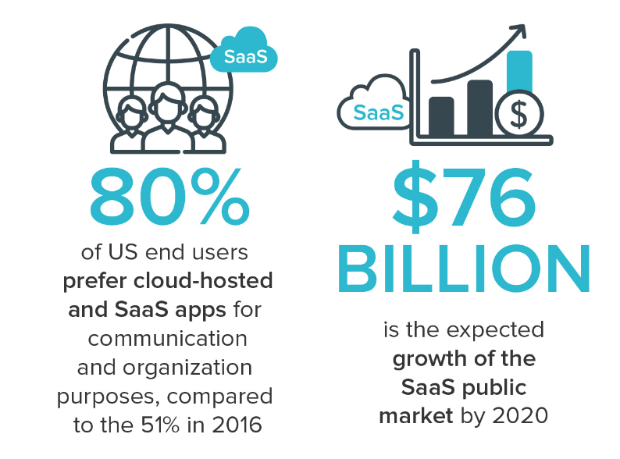

*Figure 1: Illustration of trends for SaaS (AALPHA, 2020)*

Most business platforms today run on the Cloud, this helps to work on the go for staff and reduces extra store space required to store serves, and maintenance costs. Due to fact that most business move the SaaS model (Software as a Service), it will be profitable for the Supermarket chain to move the IT Infrastructure to the Cloud. (FinancesOnline, 2020)

Upgrade will make expansions and future upgrades to the IT Infrastructure more flexible and safer from damages as personalized services as offered by partners businesses. If the Company requires to store company’s sensitive material, the old servers can be utilized for this, making the upgrade more economical and approachable to the company.

Statistics show increasing trends for people requiring working from home and for administrators requirements to maintain systems from one service point where actions can be assigned, monitored and controlled. This shows clear evidence for the requirement of the supermarket chain to move to cloud-based infrastructure as studies done by FlexJobs and Global Workplace Analytics shows “that there has been a major upward trend in the amount of people working remotely in the U.S. In the span of one year, from 2016 to 2017, remote work grew 7.9%. Over the last five years it grew 44% and over the previous 10 years it grew 91%. Between 2005 to 2017, there was a 159% increase in remote work. In 2015, 3.9 million U.S. workers were working remotely. Today that number is at 4.7 million, or 3.4% of the population.” (flexjobs, 2020)

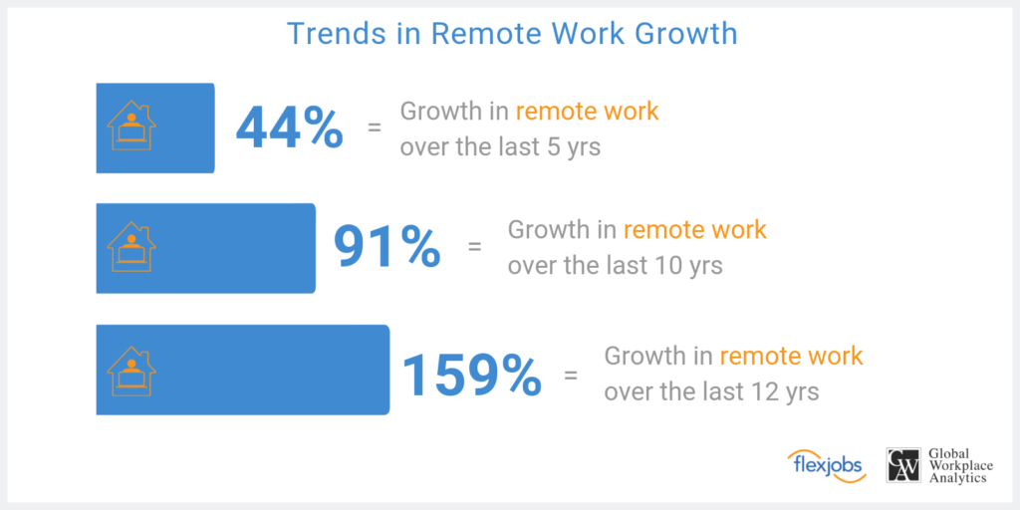

*Figure 2: Illustration of Growth in Remote Work (flexjobs, 2020)*

As to the provide scenario in the assignment brief, this supermarket chain is planning to modernize their operations by tracking their goods’ statistics like quantity, sales rate, coordination of regional departments and to provide online shopping services.

Day by day passes by the ratio of consumers buying their goods from online than attending to the store is raising gradually. So, companies should start providing their services via online to gain a profitable margin in the years to come. This interacts directly to providers like supermarket chains as they provide to extreme essentials people require daily.

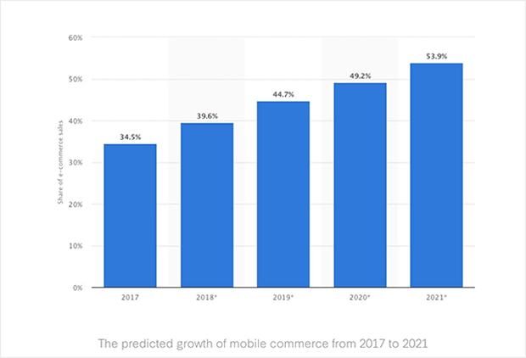

*Figure 3: Illustration of Statistics Raising for Online Shopping (Ouellette, 2020)*

According to the future predictions of online shopping there will be 54% dominating the sales sector in 2021. This means half of the goods sold are either delivered to the buyer’s home or product is sent to a pick-up outlet. The main purpose for the majority interested in online shopping is due to the consumer time allocation to execute the task is less. But in terms of store shopping the instant interaction and purchase of goods is the beneficial perspective.

This supermarket chain’s main goal is to implement their own IT system and infrastructure to operate the supply chain efficiently and reliably. This brings to different perspectives in benefits and drawbacks for this supermarket chain.

Benefits:

* Data operated in the IT infrastructure is physically located under the supermarket chain’s supervision and full control over their data.
* Can instantly maintain the network and hardware equipment is necessary,
* There are less vendor limitations in further developing the IT infrastructure.
* Physical interaction to the hardware equipment will only be done by the organization’s trusted employees.

Drawbacks:

* Additional IT sector in the organization is required to monitor and maintain the network.
* More costly to run an IT infrastructure by the organization than handing over to a vendor due to the maintenance of constant usage in electricity, data bandwidth, and water. Monitoring and managing a network take a lot of resources as it’s an addition operating cycle for the organization. An IT infrastructure required for such organization requires servers, these servers are meant to be handled in certain environments like the temperature should be 19 to 24 degrees Celsius and the humidity should be at 70%. Backups systems like power back solutions, data backup solutions are required.
* High security threats and lack of experiences in handling such incidents.

These are just several benefits and drawbacks the organization would face after the installation of their own IT infrastructure.

And one drawback would be this IT infrastructure requires a tactical planning by professionals and hire skilled people to operate this new section of the daily operations. This is a crucial element as it leads to the outcome of the supply chain.

During this progression, the supermarket chain is planning to implement several functionalities,

* An option to shop online where consumers can receive the goods home delivered or collect it as a pick-up outlet.
* Quantity of goods available in the outlets and regional stores will be monitored and new stocks will be requested from the distributors.
* The monitoring and management of the supply chain will be handled by the head office of the supermarket chain 24/7.

They plan to implement such services by the use of IOT (Internet of Things) and GPS devices. Also, the security of network infrastructure will be secure as to the monitoring of the daily activities done in the supply chain.

Details about the Infrastructure

Each of these infrastructures has their own pros and cons and as the heads of IT operations it is our task to determine an infrastructure that is suitable for the organization. here is some information about each of these infrastructures which may be helpful when deciding an infrastructure for the business.

Traditional server deployment

The traditional server deployment has its pros and cons which may affect the decision of the infrastructure. Some of the pros are High performance and specialized hardware and another advantage is that. The disadvantages are inability to virtualize and expensive disaster recovery and these are only some of the drawbacks to this infrastructure and should be considered when choosing.

Virtualized deployment

Server virtualization is a software architecture that allows more than one server operating system to run as a guest on a given physical server host. Some of the virtualization platforms are VMware, Xen and KVM. The virtualized deployment has its pros and cons some of its pros are less maintenance cost, less physical server and less energy cost. But this infrastructure also has some cons sing point of failure and high stress on single machine. So, deciding whether this infrastructural is perfect for the business depend on the type of business and functionalities the business needs to provide to the customers.

In-Housed or off-site based deployment

This infrastructure also has its pros and cons when it is chosen Just like the other infrastructures. Some of its pros are that Gives you physical control over your backup, keeps critical data in-house so No third party has access to your information and No need to rely on an Internet connection for access to data. Then there are some disadvantages for this infrastructure, and they are Needs space in your workspace for a rack or server, dedicated IT support and No uptime or recovery time guarantees. So, it depends on the business whether this infrastructure in suitable to the business.

Project success

The project will be a success when the correct infrastructure is chosen and has a clear understanding why this specific infrastructure is better than the current and from the other options that were available and what are the new functionalities it will provide. In addition, the infrastructure should be implemented and completed within the given time period and the budget for the project to be successful.

In the given scenario we must implement a supermarket infrastructure to make the current transactions efficient. The supermarket infrastructure consists of

* Sales outlets (supermarkets).

Provide shopping facilities to online and traditional Customers. The Online purchases will be delivered via transport or customers will be able to pick it from the nearest supermarket.

* Storage and logistic centres.

The stocks sent from farms will be stored here. Depending on the demand provide supermarkets with stocks.

* Transportation system

Transport goods from each outlet.

* Head office

Implement security via a command and control station.

Communicate to any outlet, security focal point via and AOIP.

Monitor every location via CCTV.

Track transportation via GPS and IOT.

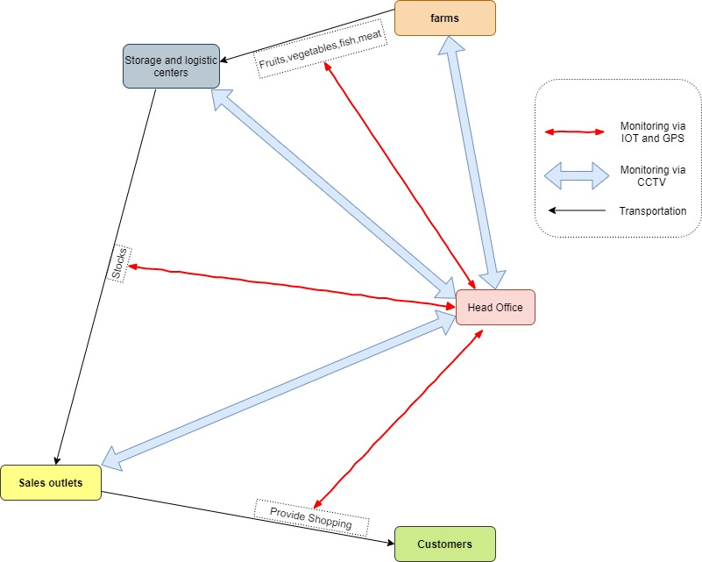

*Figure 3: Illustration of the Food Management Network*

Project Requirements

* Explain the possible infrastructures in detail (the technologies they use)
* Identify the External and internal users of the current system
* Compare each of these infrastructures with one another (Identify weaknesses and strength of each Infrastructure).
* The current trends / technologies used in Supermarket industry.
* Why the selected infrastructure is better to the given scenario?
* Diagrams of the implemented Infrastructure

# 3. TECHNOLOGY JUSTIFICATION

## 3.1. Cloud Services -

Today productivity and innovation in a business is a key, few years back cloud computing was an emerging technology but today, it’s being used by airlines, banks, IT companies and almost anywhere we see people use these cloud services from secured online meetings and transactions to personal movie entertainment. Today users are interacting with the cloud than ever before in fact statistics at the time writing show the data usage in a second is nearly 100,000 gigabytes that are made to the cloud. (Our World in Data, 2017)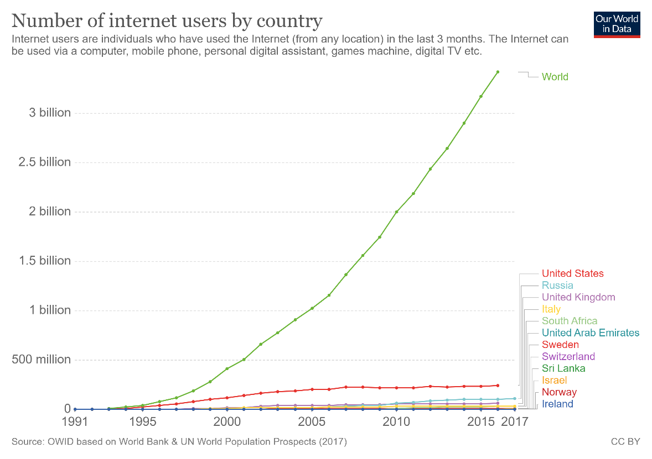

*Figure 4: Graph of Number of Internet User (Our World in Data, 2017)*

Types of cloud computing

There are three types of services on a public cloud, private cloud or hybrid cloud.

**Public cloud**

Public clouds are provided by third party vendors to clients they offer these services usually for free or exceptionally low costs, all the software and hardware are managed by the vender and they allow client to access these resources over the internet virtually.

**Private cloud**

A private cloud usually is stored on a company’s premises for their business use only, this is comparatively costly compared to the method where vendors host the data on their private cloud offsite for low cost as they can virtualize and share resources.

**Hybrid cloud**

Hybrid clouds combine public and private clouds allowing much flexibility for access content within the private and public clouds, this allows a working officer to use the company’s public website to login securely to companies’ private resources with properly authentication. Most business use the hybrid cloud technology today.

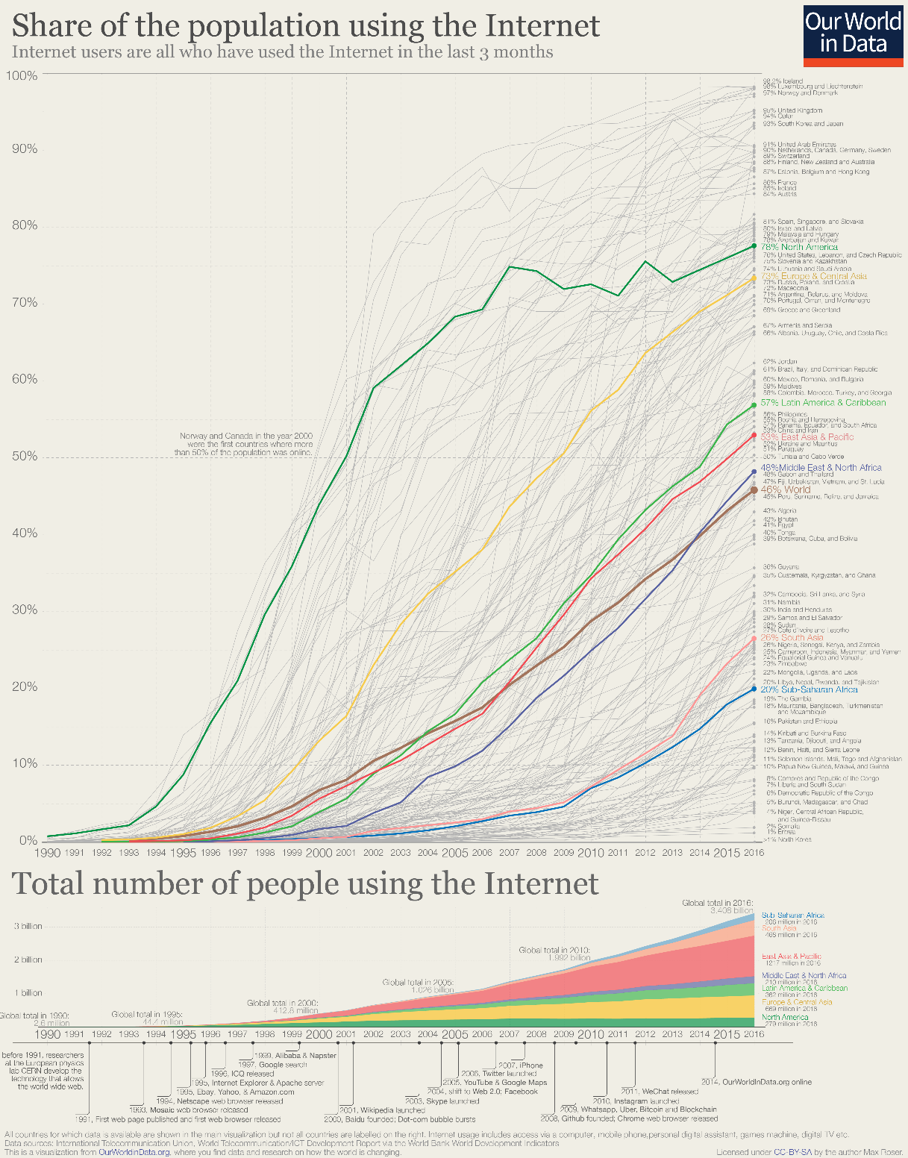

*Figure 5: Graph of Number of Internet User in the World (Our World in Data, 2017)*

Types of Cloud Services

**Infrastructure as a service (IaaS)**

IT infrastructure which includes servers, storage and other hardware are provide for a rental which make this a good choice for most entrepreneurs. i.e. AWS, Microsoft Azure.

**Platform as a service (PaaS)**

Platform as a service offers the required hardware and software to be accessed online, similar IaaS but offer more flexibility on selecting a separate operating system and other hardware as platform for software without high level server management. i.e. Google App Engine.

**Software as a service (SaaS)**

Software as a service allows users to access and use application using a web browser or similar tool by loading only required assets to the client end, this allows much flexibility and content can be access from any device that has web browsing. i.e. Office 365 Online, Jira, Github.

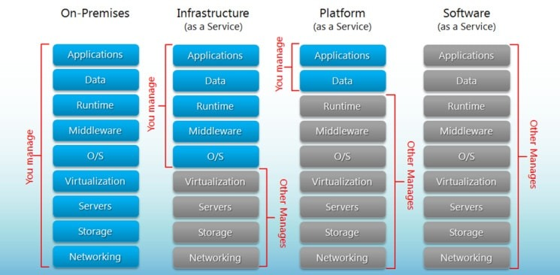

*Figure 6:Comparison Illustration of Iaas, PaaS and SaaS (BigCommerce, 2020)*

Advantages

* Cost Efficiency – Compared to traditional method implementation, maintenance and upgrading cost are exceptionally low. New cloud-based systems are very economical for both startups and large enterprises.
* Backup and Recovery – Data available on cloud allows to quickly restore data and failure rate is low as there are multiple servers to save copies of the same data.
* Storage – Cloud storage allows users to expand storage at very low costs compared to on premises storage disks, it saves costs on expanding building size for storage requirements and economical.
* Speed – Most services provide edge speeds with cloud storage, when they use SSDs but to be benefited by this technology customer should have an internet connection with a good bandwidth of at least 10MBps.
* Global Scale – Cloud systems are assessible from anywhere without extra costs and allows to integrate and work with multinationals with ease, in fact cloud services make little impact on client’s storage, processing power and bandwidth.
* Security – Most issuers supply a satisfactory level of privacy configuration and controls for management and connections are secured using network encryption and storage encryption.
* Performance and Reliability – Datacenters upgrade their components regularly which offers users the best in class experience with their service. With new implementation plans there is less downtimes and slow down as data is accessible from multiple datacenters around the globe.
* Productivity – Deployment of services could be done within few hours compared to on premises storage that usually take weeks to get configured in most cases.

Disadvantages

* Security – There’s considerable risk of data theft when selecting cloud storage as the IT infrastructure of a business in the past, confidential data and financial records have been compromised.
* Network – In order to be benefited clients need have an active network connection and an above average bandwidth to keep a constant connection with the service.
* Technical – There can issues as servers are prone to DDoS attacks and suffer downtime, sometimes even cloud services suffer from internet and power issues which effects client’s business as they have limited functionalities to manage the cloud.
* Vendor Lock-in – Migrating from on cloud service to another is not flexible but new services are being built to mitigate these limitations such as cluster sharing that are provided by SQL Server.
* Support – Communications between the cloud provider and client takes time usually emails take 2 working days or weeks for a response on busy weeks this isn’t acceptable for most businesses.

Cloud computing offers both advantages and risks to a business if not properly implemented, considering all facts it would be better to store highly confidential static data on premises and other data on the cloud which requires regular interactions.

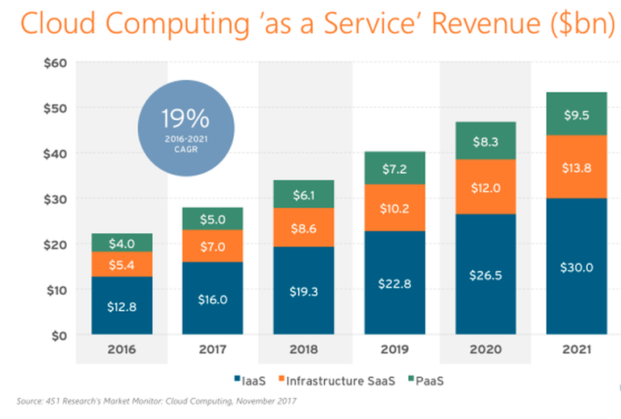

*Figure* 7: Illustrations of the cloud computing services revenue for the current period. (Ranger, 2020)

Currently the revenue gained from cloud services are rising than the rate the analysts has predicted. This means that nowadays many clients rely on cloud services as they provide the more resources for a lower cost.

## 3.2. Traditional Server Deployment -

The Advantages

* High Performance- Since all the recourse are dedicated and it can handle high stress scenarios.
* Easy to identify problems – It is easy to identify the problem and only one server will fail at a time.
* Easy to use- Since this technology has lasted for a long time there is a small learning curve for the IT department.

The Disadvantages

* Price- The equipment cost will increase over time because more application is equal to more servers and gradually there will be a huge amount of cost for hardware.
* Lack of growth and consistency- Since in order to grow we need add more servers and to do this physical space is needed and management of servers can be difficult, so it lacks growth and is inconsistent.

## 3.4. Virtualized deployment -

“Server virtualization is the process of using software on a physical server to create multiple partitions or "virtual instances" each capable of running independently”. And we must clearly understand the benefits and disadvantages of using this deployment rather than the other options we could choose from. we could use this deployment if we are planning to reduce the application downtime and simplify backup process or Use more applications and OS without breaking budgets for hardware, electricity, and space and there are more scenarios where this deployment would be preferred so when choosing we must ensure it satisfies our business requirement. In addition, in server virtualization there are three types of server virtualization and they are Virtual machine model, Paravirtual machine and OS-level. So, choosing the type of virtualization of server is also important because it can affect the business.

The Advantages

* Reduced Hardware Costs- Since there are fewer physical servers this will reduce the initial hardware cost that is required for the equipment.
* Growth and Scalability - Since it is running a physical server if we upgrade it then all the virtual instances will also get, and upgrade and another good thing is that less hardware complications and the main thing is it is easy to grow.
* Energy Cost Savings- Since there is fewer physical servers this will reduce the energy cost at a huge rate.
* Simplified backup and recovery – Virtualized servers are easy to recover data because the virtualization software’s has a feature for backup and recovery. This may be from cyber-attack to natural disaster still the data can be recovered.
* Security – A virtualized environment makes it easier to manage the security of the server.

The Disadvantages

* High cost for initial setup – Even though overall cost is reduced there is a high cost for initial setup since there is licensing and more.
* It’s not Easy – There is a big learning curve since there are many different types of architectures and different types of software.
* Slow performance – There is a slow performance because of all the stress is on a single machine which my result I longer processing times and finally there are network bottleneck.

## 3.5. In-Housed Deployment –

In house server are the servers that are installed within the premises of the organization.

Advantages

* Keeps critical data in-house - Since all the data is within the premises no third party will have the information that is stored, and we have total control of the data
* No need to rely on an Internet connection – The business do not need to rely on the internet to access the data this may be rally helpful if the business is located in a low connection area.
* Can be more cost-effective for small to mid-sized companies- We do not have to pay a monthly fee like for the cloud and since we have control, we can upgrade the server to meet our business requirements along the line

Disadvantages

* Requires a capital investment – A large amount of capital investment is required for the hardware equipment and the infrastructure and this is one of the main disadvantages.
* Needs space – This type of deployment needs space for the servers and more space may be required if we plan to add more racks in the future in addition needs a dedicated IT staff to handle this equipment and make sure everything is working fine
* May be more susceptible to data loss during disaster – The reason is if the business is in an area where natural disasters are common then have an inhouse servers in not a good idea because there is a higher chance of data loss due to these disasters.
* No uptime or recovery time guarantees – Since we take full responsibility, we cannot guarantee a recovery time like data centers.

## 3.6. Offsite Server Deployment –

It is when the company’s data is stored of the premises of the organization in a data center.

Advantages

* Reduce Cost – Storing data in a data center lower the expenses because all the hardware cost, maintenance and energy cost is reduced.
* More Space- We have more space for other things because all the server space is no longer needed for the servers.

Disadvantages

* The main drawback of offsite is that we do not know enough of the data center and it is important that we decide carefully and do some research on them and ensure they have a good record because we will be trusting them with our data.

# 4. DISCUSSION AND CONCLUSION

### Mr. R.P. LADDUWAHETTY’s Solution

Suitable technology for this implementation would for cloud storage as it will be future in businesses, due to the fact that this organization isn’t an IT based client instead in food chain market, going for cloud based solution would be better to improve their services and will be economical. Introducing a new hybrid-based infrastructure to store confidential data within the premises and storing the web server outside the services would be ideal. Customer will be able access the organization website without issue and will have a better uptime compared to the onsite hosting, working agents of the organisation can access the organisations resources for working using VPN routing safely, the Hybrid solution of on premises and cloud storage is a good choice as the food chain organisation being large enough to maintain and handle costs so, it would viable for the organisation to choose a trusted vendor for SaaS and do the on premises implementation although there are economic factors this procedure helps to enhance productivity by allowing workers to work from anywhere and keep the intranet less likely to be attacked by implementing proper security management systems and network security such as TLS.

### Mr. W.A.D.N.N. WIJESURIYA’s Solution

The technology I think that is suitable for the business is in house deployment. The reason is that the advantages surpasses the disadvantage of using this infrastructure. Inhouse deployments main advantage is that we have control over everything and do not have any third part getting our data, this will reduce a lot of security issues that may have impacted if any other infrastructure is used. In addition, since it has high performance and is reliable no matter the internet connection it is ideal to use. When in-house deployment is compared with cloud computing infrastructure the cloud can’t store sensitive data such us medical, government or financial due to regulatory and compliance laws (Storage Craft Recover Zone, 2020). In addition, the cloud is affected by the internet connection. Some of the other benefits of using in-house deployment is that the business could run applications that are still not cloud ready. Due to these reasons and more I think that in-house deployment is the best choice for the business.

### Mr. H.V.L. HASANKA’s Solution

By the provided scenario, the supermarket chain consists of a process that flows almost 24/7. This system must monitor the current activities of the chain flow and identify some of the goods running low on quantity. The head office administrative that operate the system for managing the supermarket chain must monitor the activity of the online users making purchase via their online store. This is check for any suspicious activity. Also, the physical activities like the transporting of goods, store goods quantity is monitored by the head office with the use of IoT and GPS tracking systems. All the data that is transmitted from the devices must be stored is central location for the head officer to access.

* + Option 1: I am proposing that the company responsible for this supermarket chain should implement a private cloud solution and store all their relevant information here. Head office administrative will monitor the activity by accessing the private cloud.
  + Option 2: There is another option where they could use a hybrid solution, where their employee information and user details from the inline store are stored in a in-house server whereas the other information like data on the location tracking of the transport fleet is store in a private cloud.
  + Benefits of Option 1:
    - Less costs for operating physical equipment and more resources can be accessed.
    - There is no need for additionally skilled employees to handle the physical servers.
    - All the data is easily accessible for the authorized user as everything is available in one place.
  + Drawbacks of Option 1:
    - Third party entity, cloud servicer provider is involved into the process.
    - Cloud service is accessed via the internet. With means that hackers could involve in security risks and threats.
  + Benefits of Option 2:
    - The company’s employee information is safely stored within the company premises.
    - This information is blocked from the outside world as a local area network would be used access this data no internet is involved. Hackers cannot access this data or send security threats like distributed denial of service attacks.
  + Drawbacks of Option 2:
    - Company data is stored in two physical places, meaning that the company should manage both.
    - Must obtain and maintain the physical servers and these servers will requires power and proper cooling which can costly.
    - Additional skilled workers are required to operate and maintain the physical servers.

Best Option –

Due to the fact that this company requires a central location to gather and store data from the supply chain, option 1 – using a private cloud, would be the best solution when comparing the various benefits and drawbacks of both options. It does require a dedicated network connectivity to access the data and there is a vulnerability of security threats from hackers. But if the supermarket chain company selects a cloud service provider that is surrounded by a trustworthy antivirus security protection like Amazon Web Services the security factor would be resolved.

Secure cloud service providers have powerful antivirus guards built in, software and hardware firewalls to track the activity of the incoming and outgoing data packets, IDS (Intrusion Detection System) and IPS (Intrusion Prevention System) to monitor any suspicious activity in the network. If the cloud service provider is certified for security protection and obtains a great reputation as a top-ranking cloud service provider, the option 1 is the best solution this supermarket chain company could select.

### Mr. M.I.C BANDARA’s Solution

### GROUP SOLUTION

# PART B

# IMPLEMENTATION BRIEF

This brief will cover all assumptions we took for the implementation along with screenshots as evidence, We considered setting up a proper start up routine for each virtual machine using vApp feature available on VMware vSphere Client, so the programs within each machine won’t be affected due to delayed or broken machines. Each machine was given considerable delay time so it will be completely turned on when the machines in second group starts to turn on, we also set the machines to shutdown safely with a guest shutdown rather than an direct power off from the system.

DRS was enabled so when host are required to be sent to maintenance for upgrades virtual machines will be migrated to another host will allows them to come online or stay online if required without effecting the maintenance process.

External resources such as VMware docs and other literature material was referred to understand best implementation methods such as the NTP server is required to start after the DNS server has started and Database server to start before DHCP as it stores information in the database.

Other considerations such as using a Thin Provisioning for disks allows save storage rather than allocating them before this also allows to expand the storage for a Thick Provisioning if required.

Due to the fact the system runs on Windows machines turning on secure boot from host will protect the VM further as it’s an supported feature, upgrading the ESXi to latest version allowed to enable vMotion which protect highly sensitive data that’s gets transferred during the process. Initially we enabled security level to normal from disabled so the VMs could accessed be from console in an event the vCenter fails, this is better that strict mode but this blocks SSH requests completely, later on we enabled SSH request from only an trusted IP range and set of users such as managers and admins to access using SSH using a client like PuTTY, we think security is major factor to consider so we also configured the host based firewall aside of the provided firewalls and enabled and storage based encryption policy so even in an event the virtual disk file gets stolen it cannot be read due to the encryption.

Other factors we setup was templates of the virtual machines within the workgroup, this allowed us to created multiple copies of the same virtual machine settings and image although not an exact clone of it which was also possible in our tests, after setting up a sample domain we was able to setup roles for users much easily and allow secure access to the system as single sign on feature can be used with active directory enabled.

Finally we prepared the infrastructure using the best possible methods we learned during the coursework and by referring external literature material, we believe the implemented infrastructure is secure, robust and liable, reason for security is we upgraded all VM were possible to latest hosts and setup paths for regular patches and patch protection by notification recalls, polices for encryption and roles and access rights, robust we meant allows the system to function without problems of its own by vApp we setup sturdier mechanics for VM operations and inbuilt configuration for reliable storage allocation and enabled DRS for almost 100% even when high priority maintenances are required. Considering all facts this infrastructure becomes liable to support and sustain the business at its best.

Patches are released by VMware regularly to handle the application’s core functionality or for the seamless connectivity of third-party products in this platform like Cisco Distributed Virtual Switch. These patches are stored in patch repository and new releases are rolled out from this repository where VMware will update these patches frequently. This is done to ensure the stability of the core application and supporting applications.

Among the patch repository and the host machine, there is a link known as the URL based patching. This will allow the host to be notified through the Update Manager regarding a new patch availability when VMware releases a new patch. By default, the vCenter Serve application will use the VMware repository URL that is assigned, and this will be used to interact if the necessary settings are not modified. A custom URL can also be configured to be used this. Using either type, default URL or the customer URL is sufficient enough for the specified operation. But within the perspective of cybersecurity, the custom URL is more secure as it would be difficult for any unauthorized parties trying to access the link in between. During the configuration of a custom addition configuration is required but this will be highly beneficial for clients that store and transfer sensitive data across the network.

As to the link from the firewall to the banks' network, a custom patch URL is also an added advantage for the circumstances of the bank-based customer updates. This is because this link can be visible to the outside world, meaning that third-party or unauthorized parties could try to access the data packets flowing through the link. But if a custom URL is configured it would be difficult for the unauthorized parties to gain access into the network link.

The custom URL will ensure the security of the link than the traditional default URL which is assigned automatically.

Within regular time gaps, Update Manager will interact with the VMware and retrieve the latest up to date notifications which can be related to patch recalls (patch with a bug is requesting to revert from the host), new fixes, and alerts.

As Update Manager retrieves the notifications from VMware there are some notifications that trigger an alarm that executes a certain action. There are three types of notifications, *(Types of Update Manager Notifications, 2020)*

* Information Notifications – By clicking this notification the notifications details windows will open. And these notifications do not trigger an alarm.
* Alert Notifications – These notify the patch recalls for a patch that contains a bug. By clicking this notification, the Patch Recall Details window will open. It also triggers an alarm, as it also appears in the vSphere Web Client Alarms panel.
* Warning Notifications – These notify the fix for the patch recalls repairing the broken patches. By clicking this notification, the Patch Recall Details window will open. This also triggers an alarm, it appears in the vSphere Web Client Alarms panel.

When a bug is found in a patch, VMware will mark the patch by updating the patch metadata. This will result in the Update Manager to specify this patch as recalled. The Update Manager will discard all the recalled patches from the patch repository to ensure that no host will retrieve the unstable patch. If a user tries to install a patch that contains a bug and if it is marked as recalled, the Update Manager will notify the host and will prevent from downloading and installing to the host machine. But if the host is already running the patch within the application the Update Manager will check the currently running patch metadata and will notify the host. This will result in the user to downgrade the application to a previous patch version or pause the patch from running until a fix is released by VMware. *(Configuring and Viewing Notifications, 2020)*

Once VMware releases a fix for the patch bug, Update Manager downloads and verifies the user to install the fix the patch to resolve the issue that causes the dug. But if the user had somehow managed to install a patch that contains a bug and if this patch is marked as recalled, the user is notified that the patch version is recalled and the installation of the fix is available.

If the host machines are running offline, the Update Manager will retrieve the updated metadata (metadata.zip) file and notify the status of the patch when a new importation of data files has occurred. Once the fix for the broken patch is released and the fix is imported, the Update Manager discards the recalled patch from the patch repository and the user will be notified about installing the fix to the broken patch.

# SCREENSHOTS (INFRASTRUCTURE SETUP AND IMPLEMENTATION)

## Session (1/2) – Setup and Network Configuration

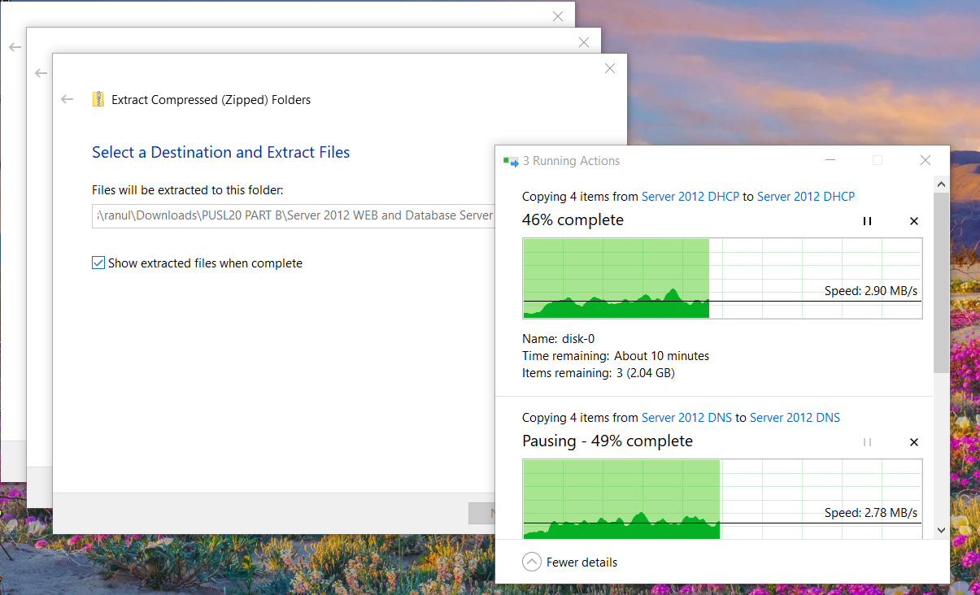

*Figure* 7*: Extraction of VM Images*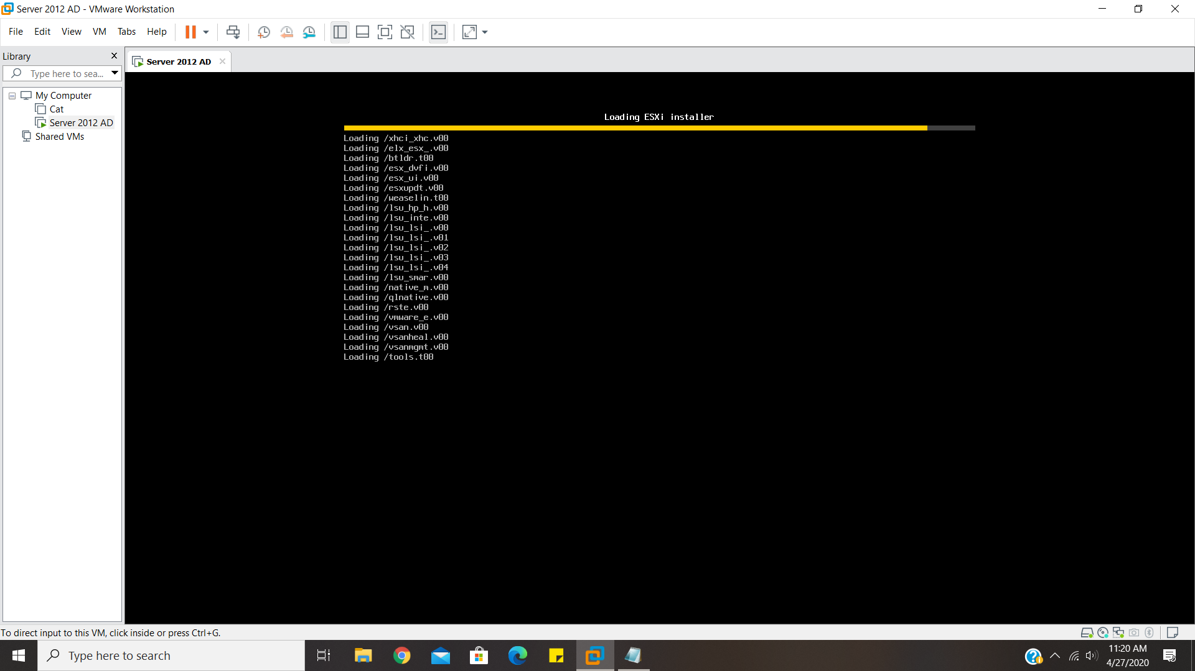

*Figure* 8*: Booting from firmware for ESXi Installation on host*

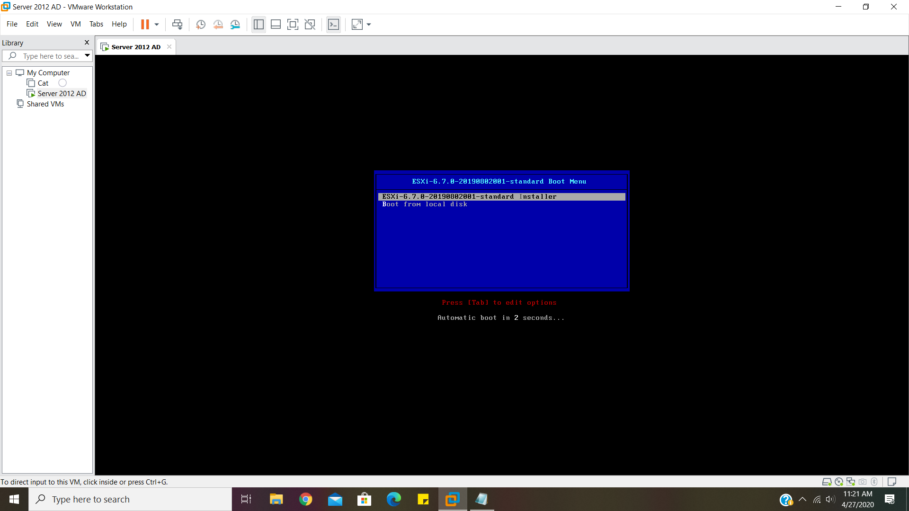

*Figure* 9*: Firmware Selecting ESXi installation upgrade*

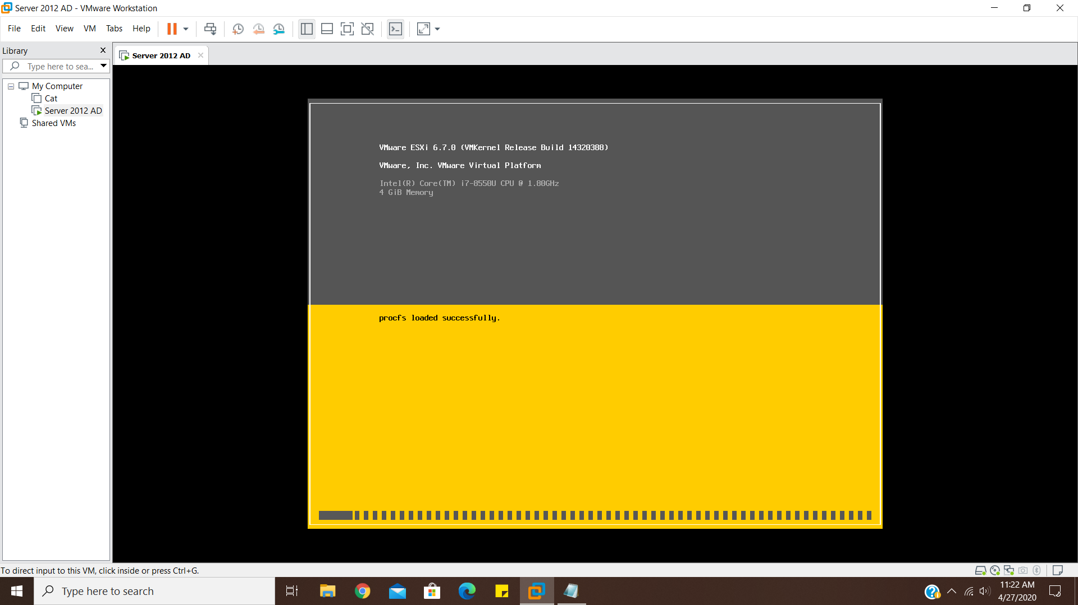

*Figure* 10*: ESXi setup Loading assets*

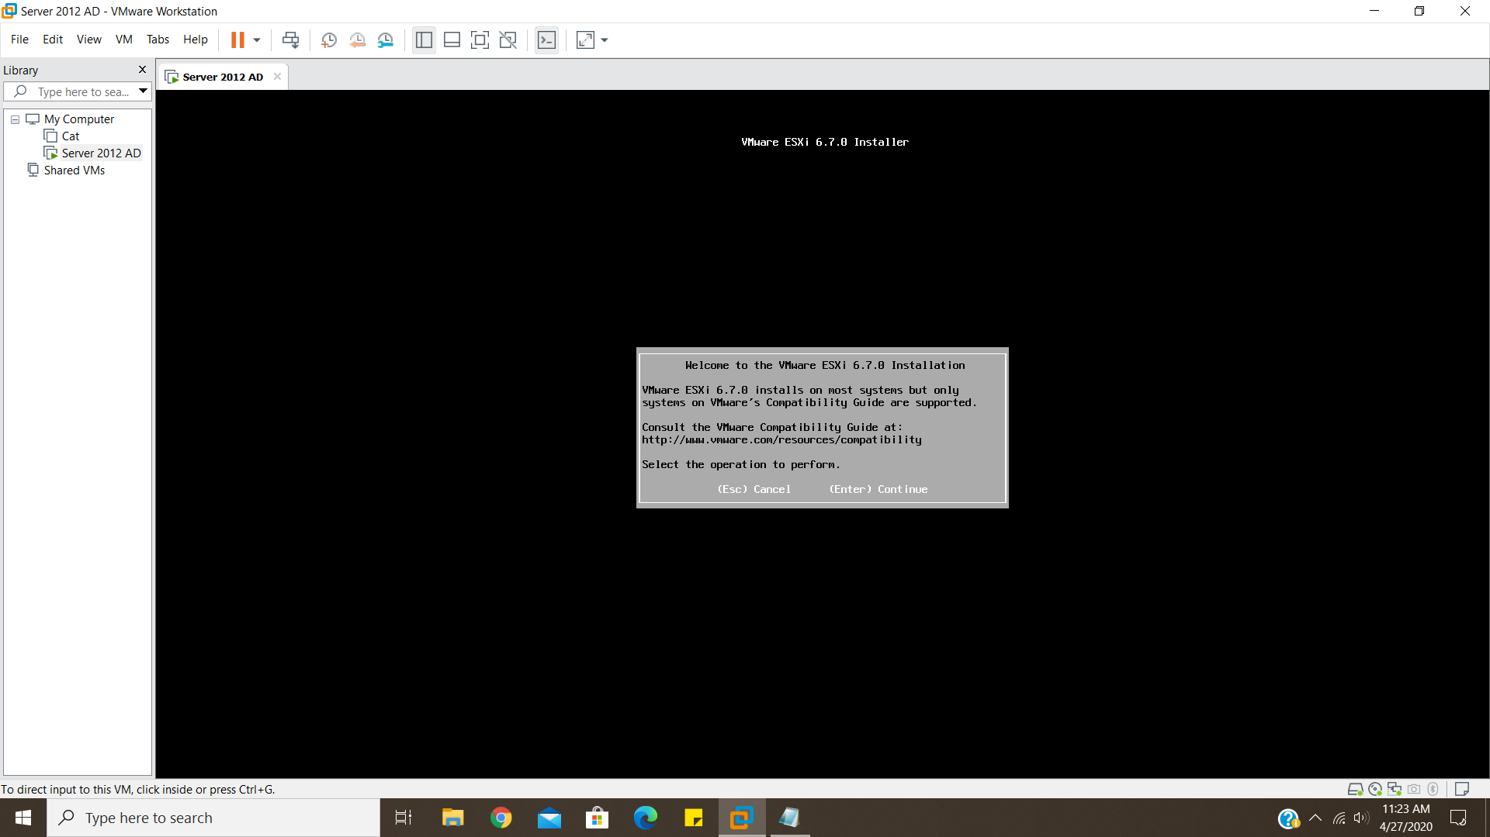

*Figure* 11*: Installation Agreement of ESXi host*

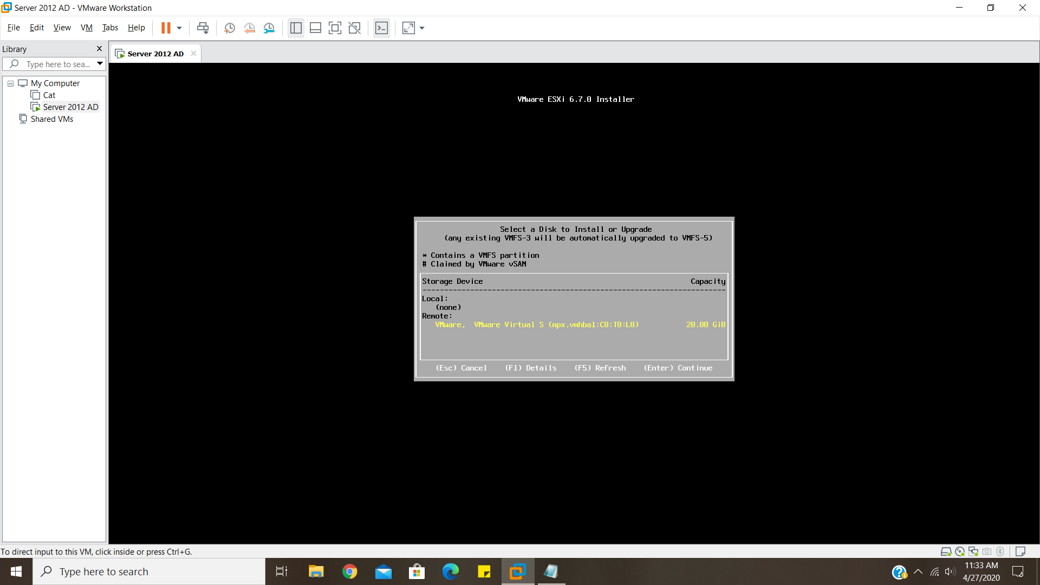

*Figure* 12*: Selection of storage for ESXi host*

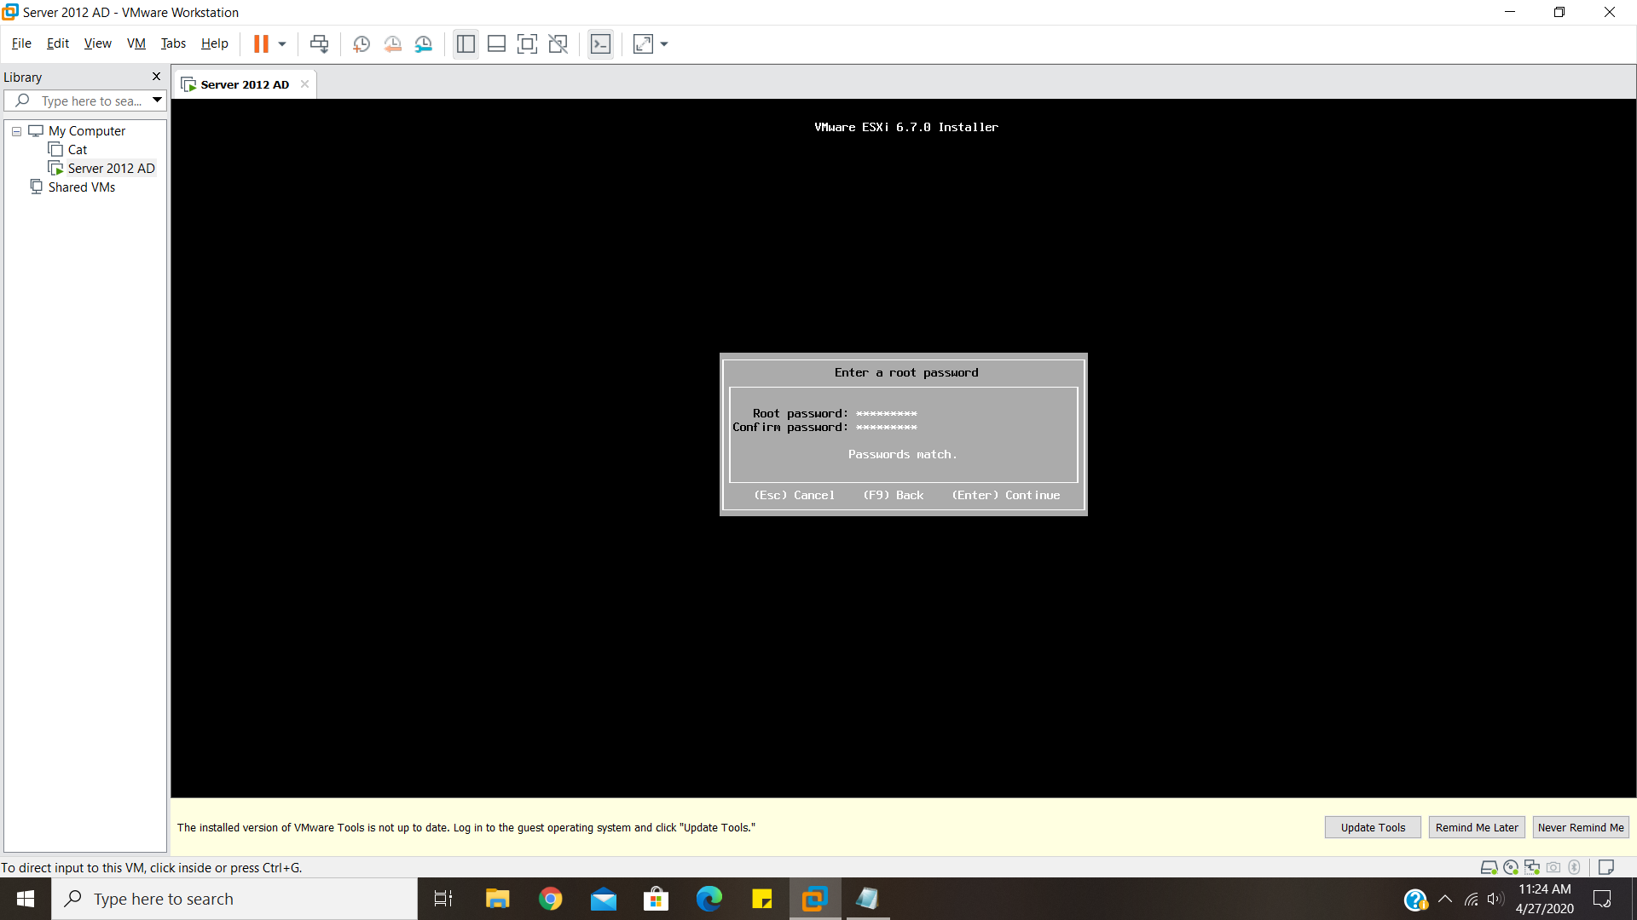

*Figure* 13*: Setting up credentials for ESXi host*

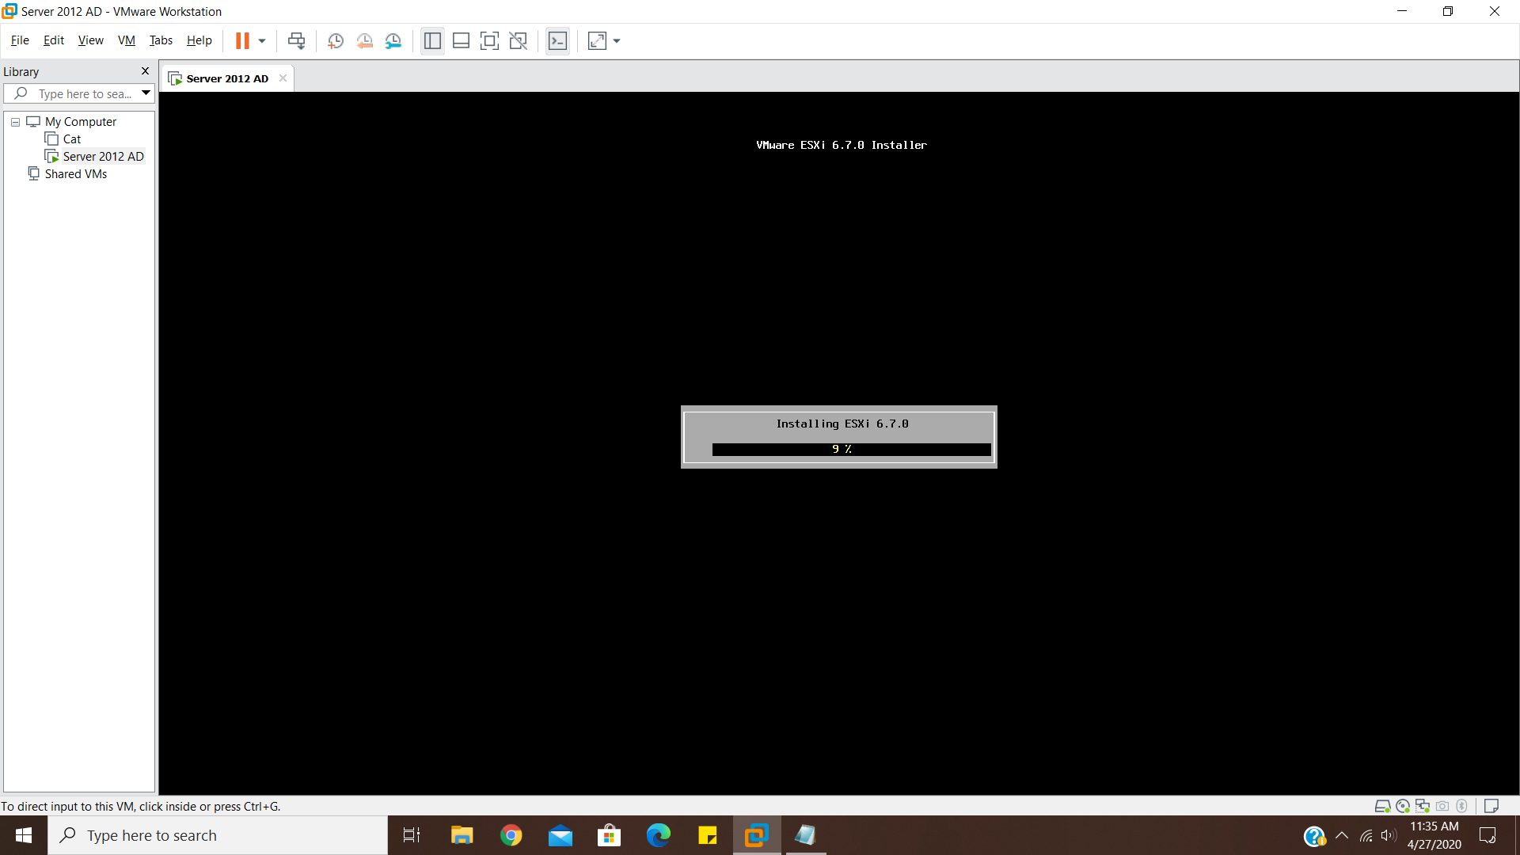

*Figure* 14*: ESXi system being installed on the host*

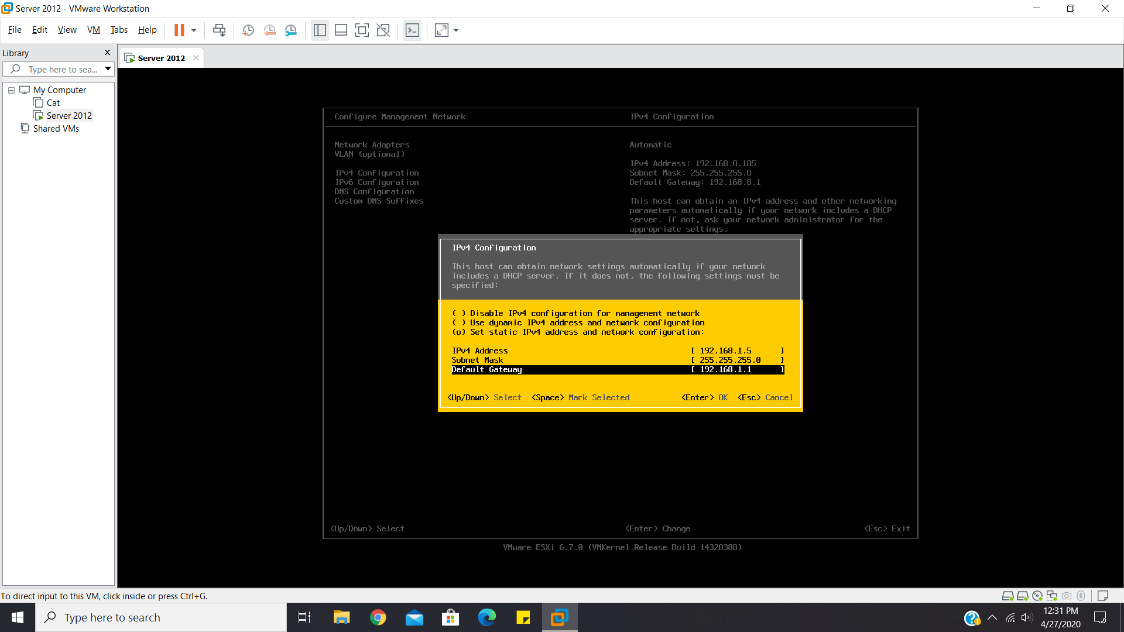

*Figure* 15*: IP configuration of ESXi host*

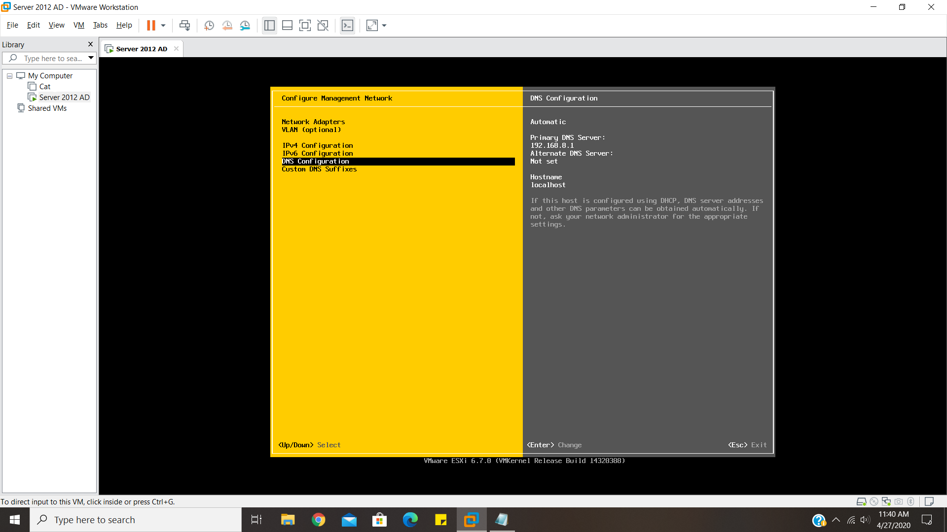

*Figure* 16*: DNS configuration of ESXi host*

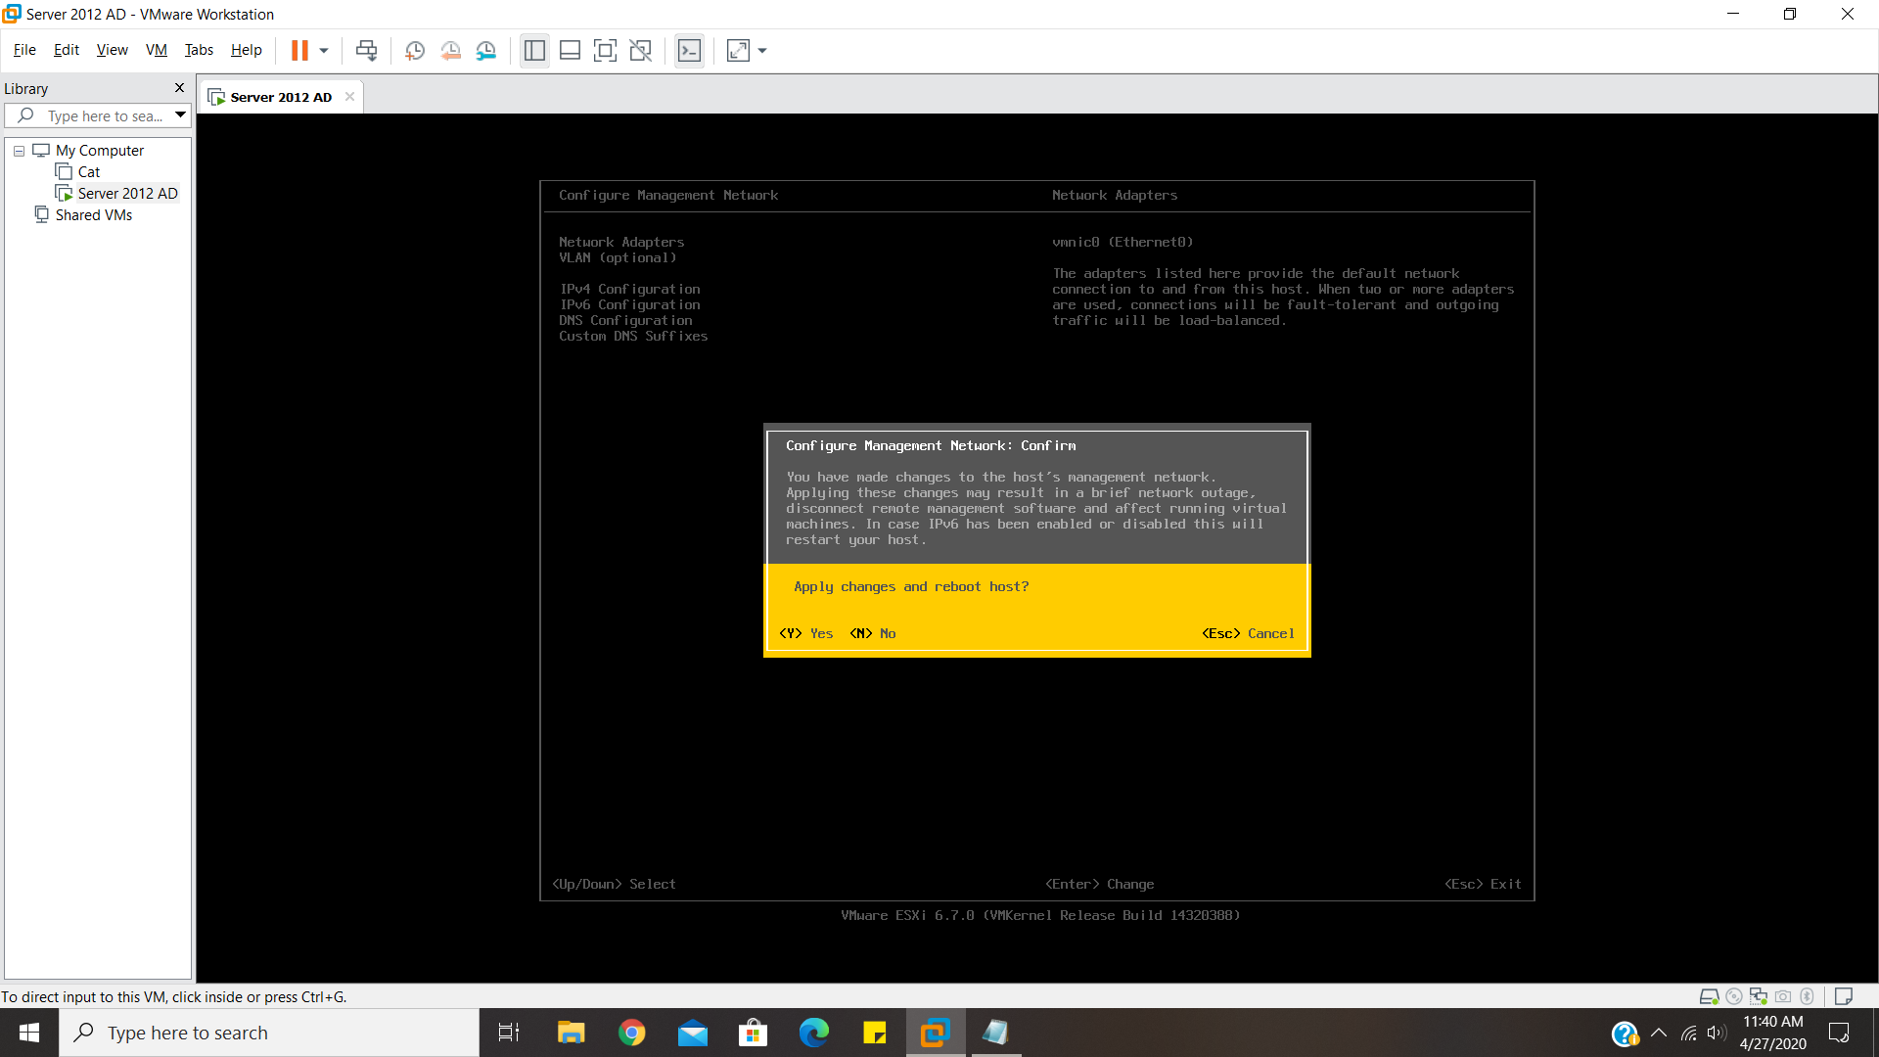

*Figure* 17*: Disabling IPv6 and other unnecessary network routes*

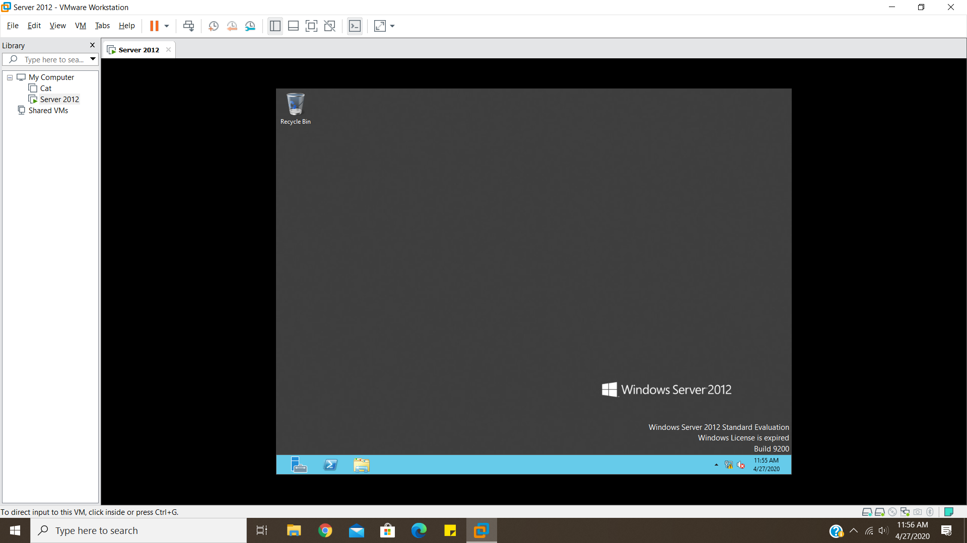

*Figure* 18*: VM image of Microsoft Server Running on Workstation*

## Session (2/2) – Infrastructure Implementation

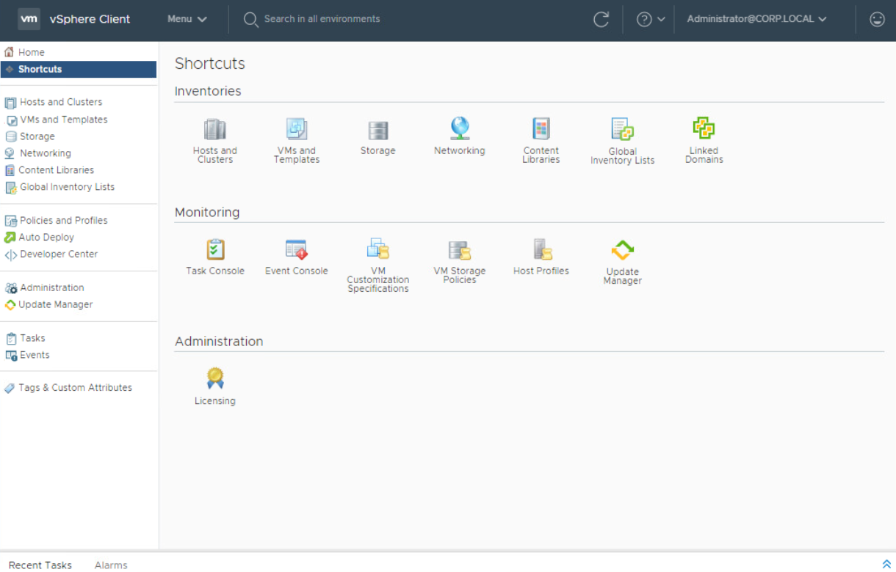

*Figure* 19*: Logged Admin to vSphere*

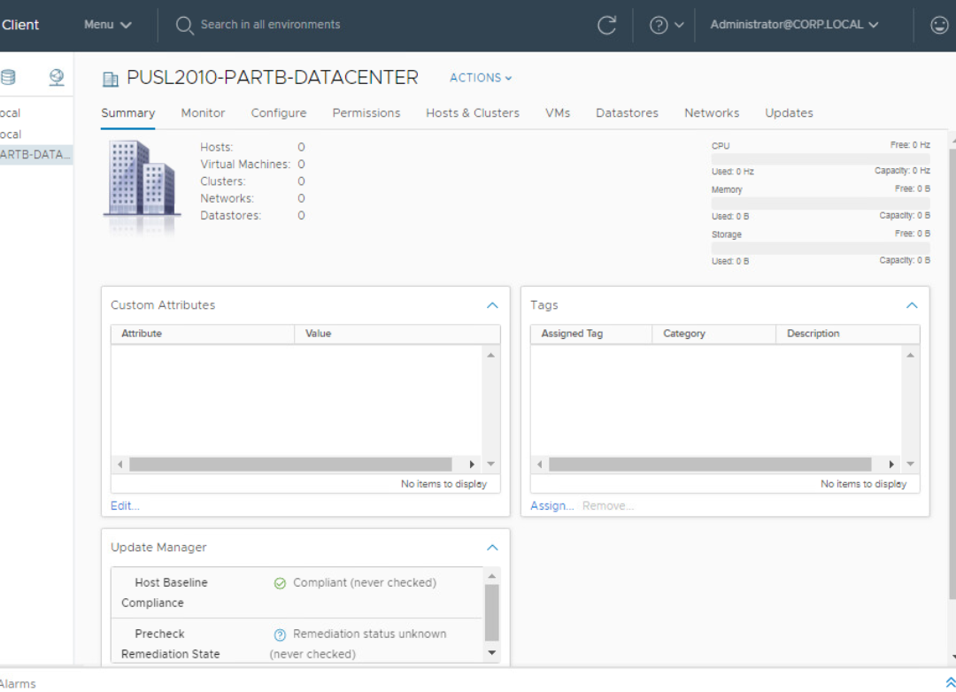

*Figure* 20*: Creation of Datacenter on vSphere*

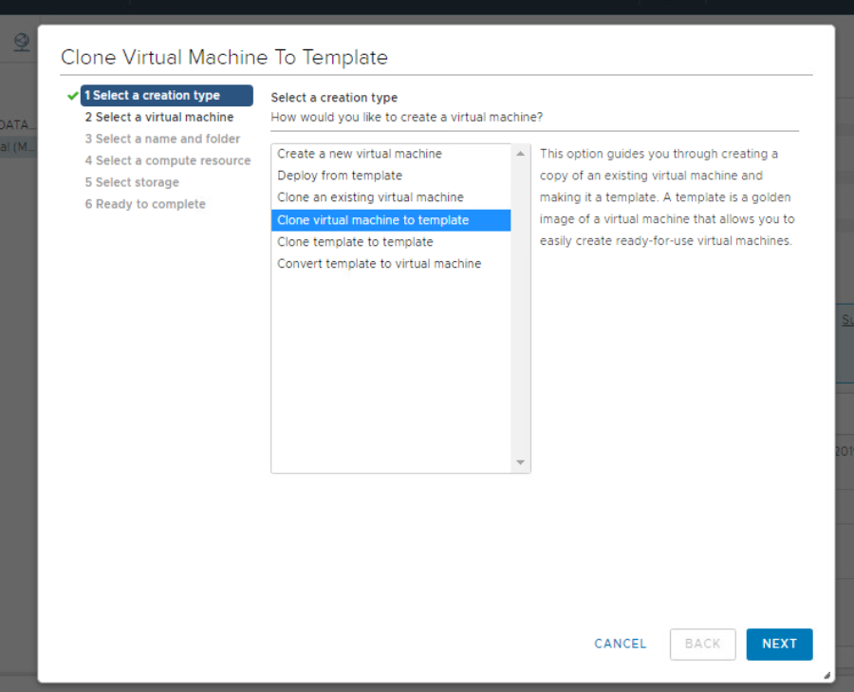

*Figure* 21*: Adding Virtual Machines to the Hosts of the Datacenter*

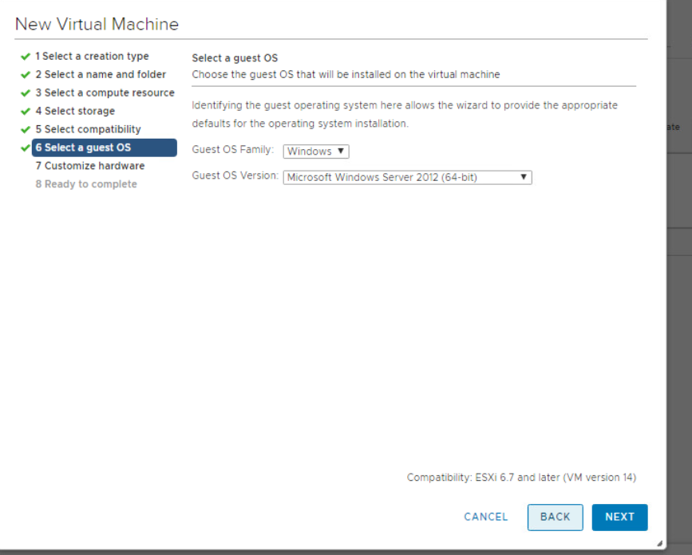

*Figure* 22*: Configuring VM for images to run properly*

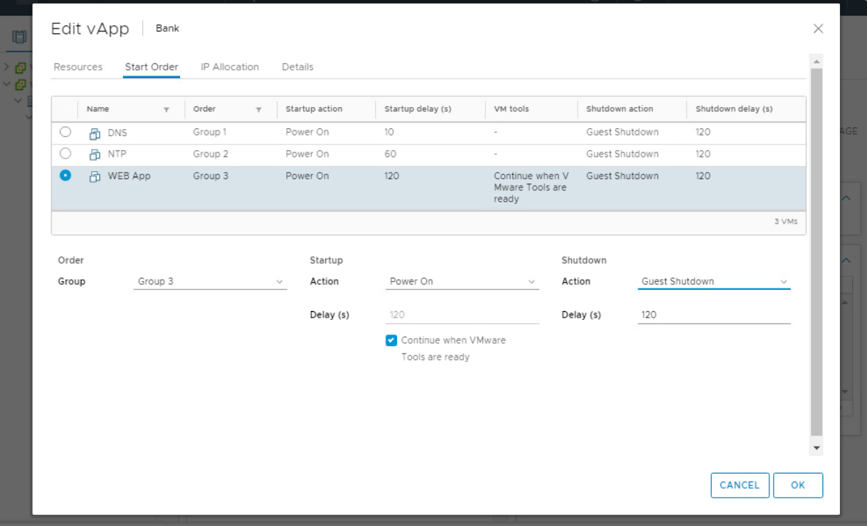

*Figure* 23*: Creation of a vApp for Bank Network to perform required startup and shutdown procedure*

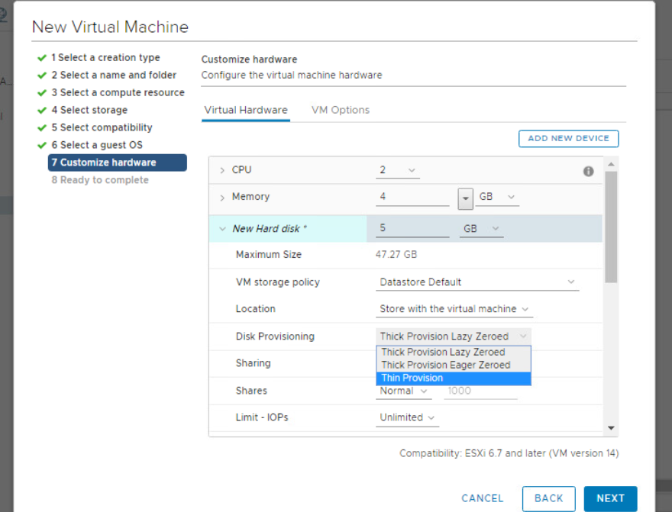

*Figure* 24*: Settings up thin provision for disk provisioning, to improve storage management*

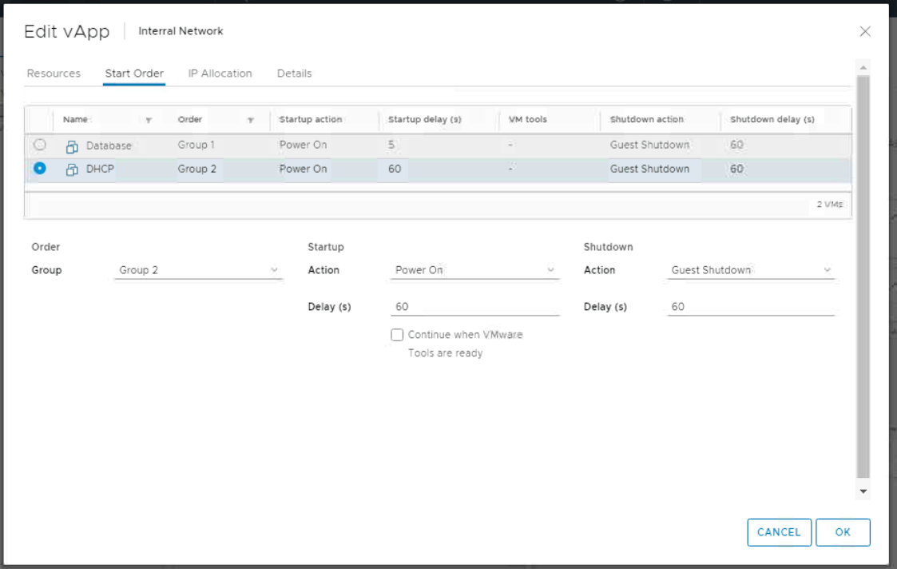

*Figure* 25*: Creation of a vApp for Interral Network to perform required startup and shutdown procedure*

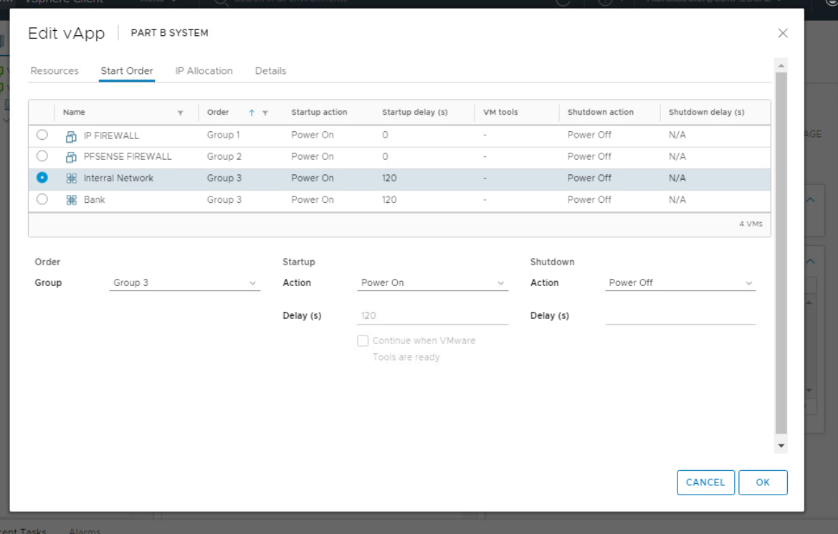

*Figure* 26*: Creation of a vApp for Complete Network to perform required startup and shutdown procedure which prevents corrupted of data and increases longevity of the hardware.*

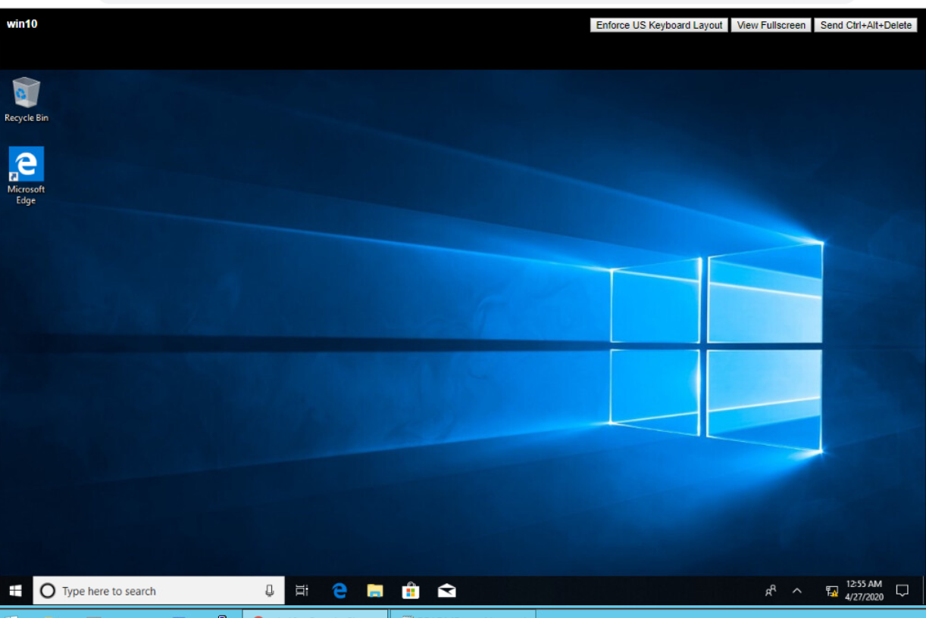

*Figure* 27*: View of Windows 10 host from web console during configuration*

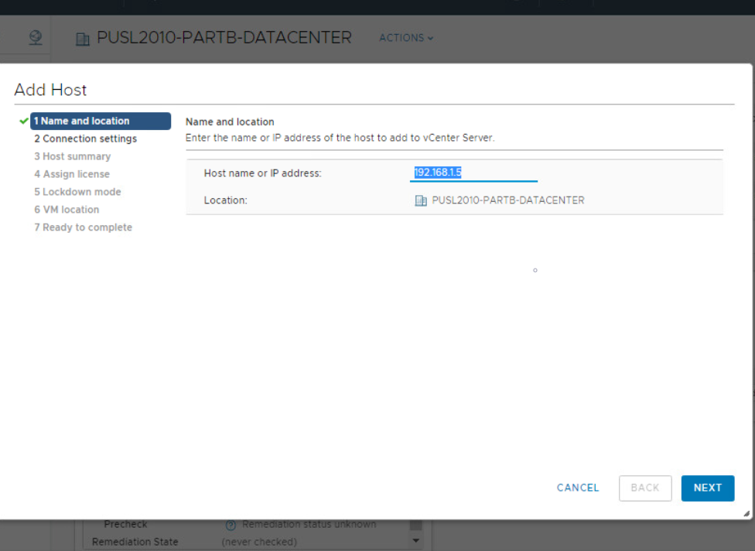

*Figure* 28*:Addition of a host to the Datacenter*

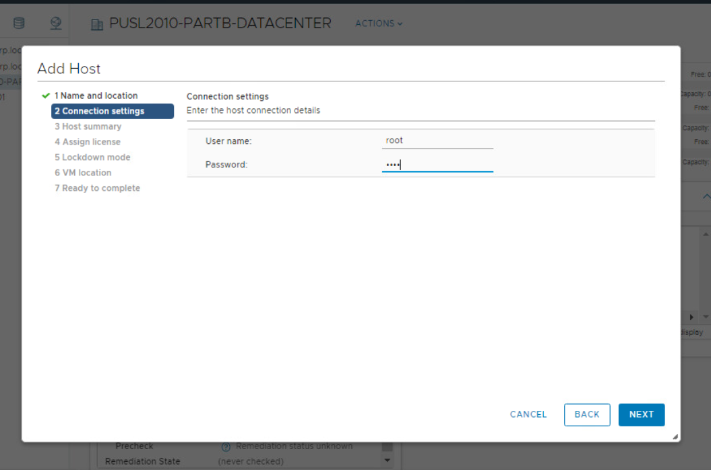

*Figure* 29*: Providing credentials for host authentication and addition*

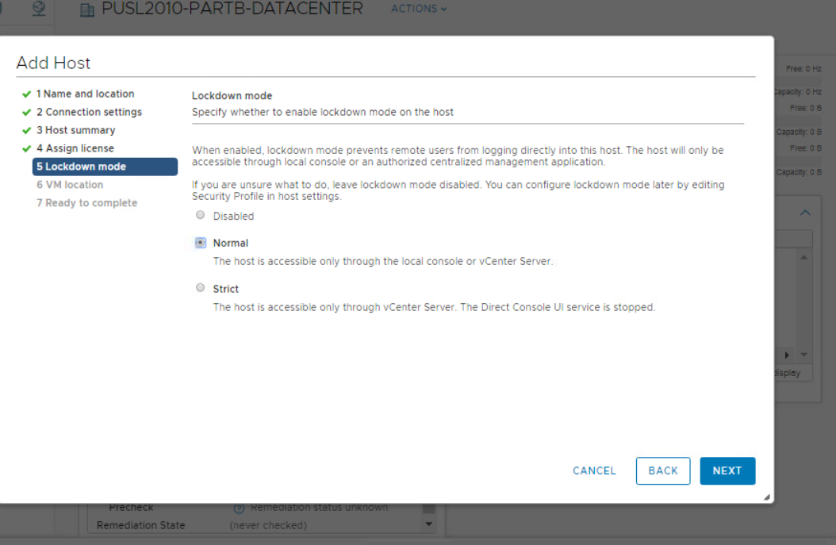

*Figure* 30*: Setting up Host Security mode to Normal to mitigate attacks from unauthorized parties.*

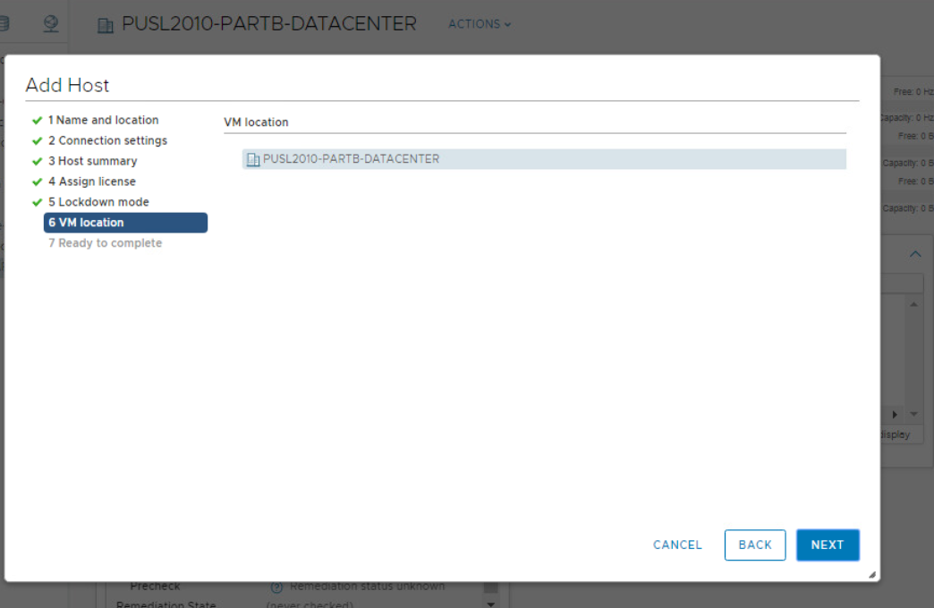

*Figure* 31*:Selecting location for Host in the inventory*

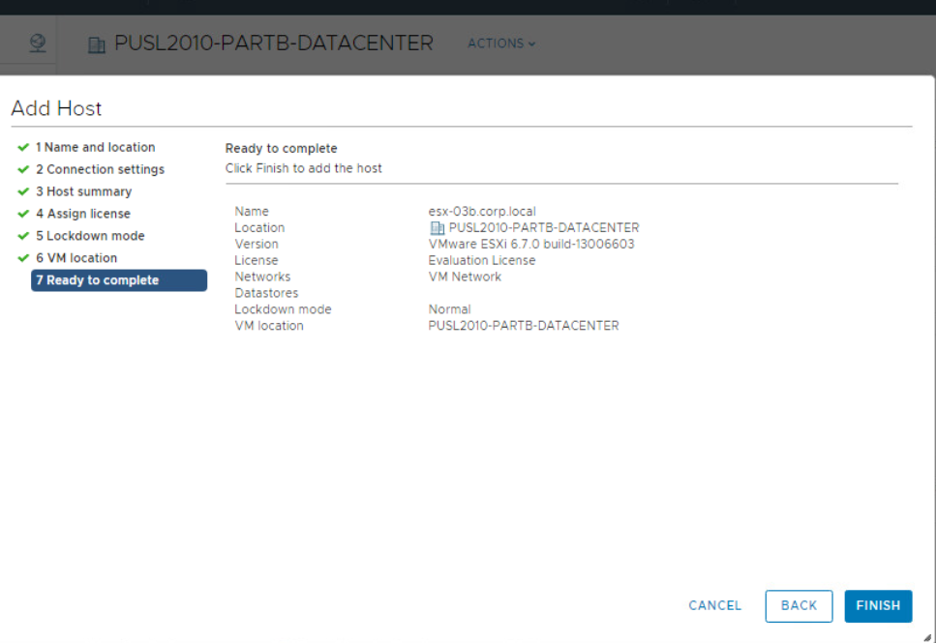

*Figure* 32*: Completion of a Host Addition to the virtual Datacenter*

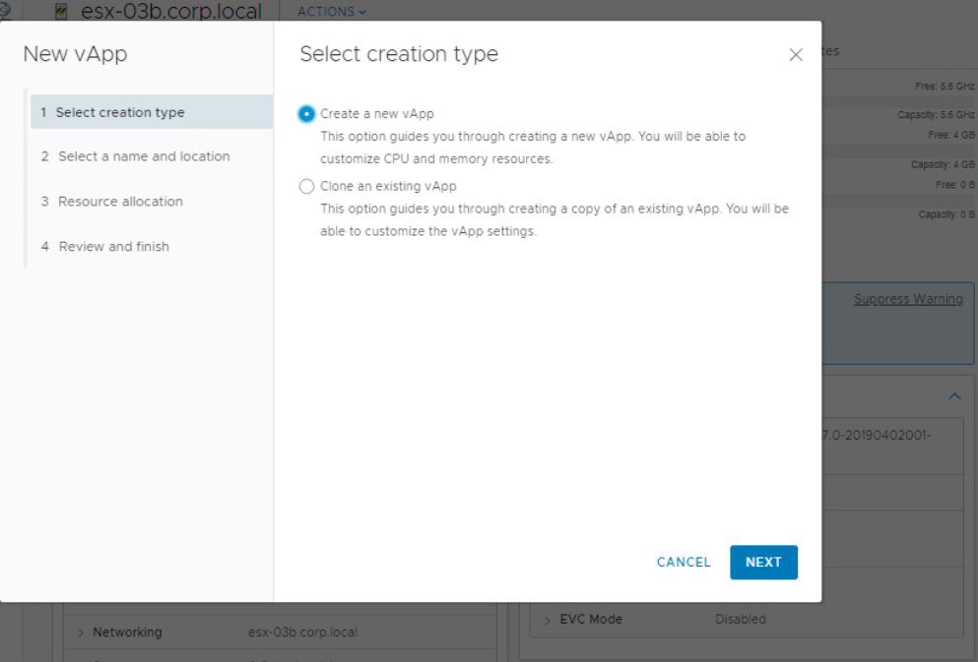

*Figure* 33*: Creation of an vApp in vSphere*

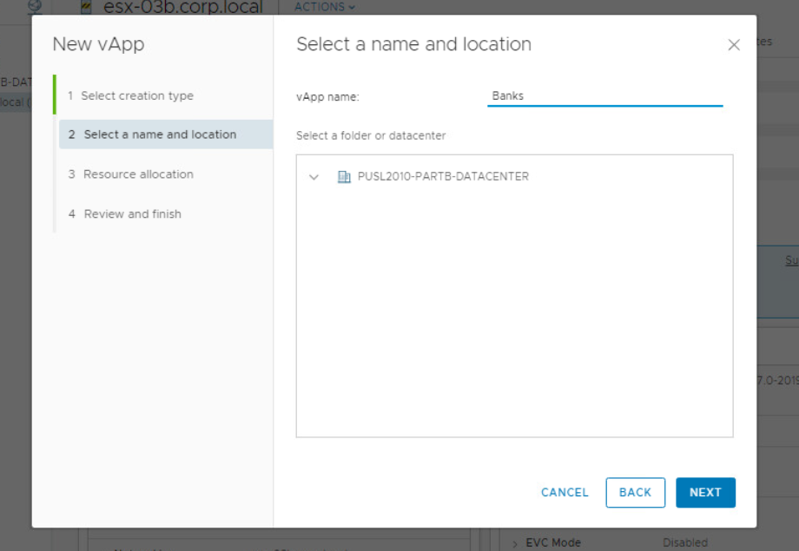

*Figure* 34*: Banks vApp creation to manage VMs in the bank network*

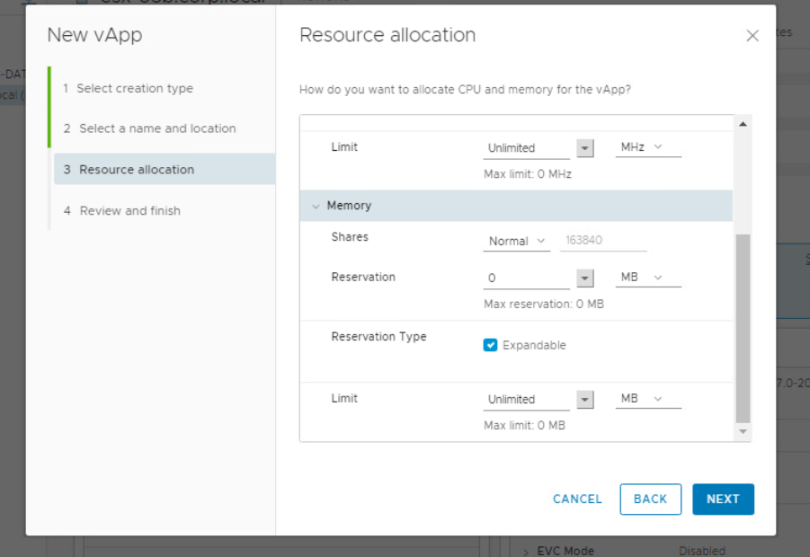

*Figure* 35*: Resource Allocation for vApp*

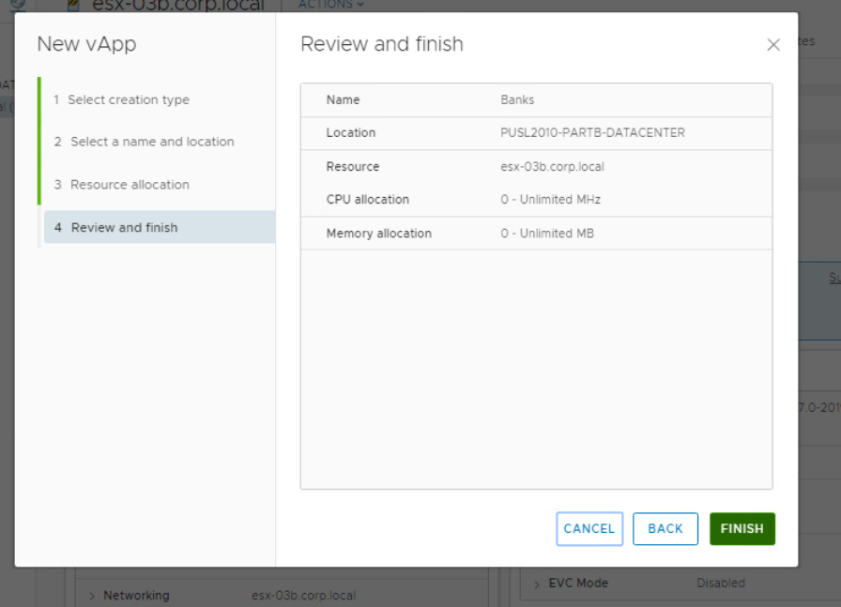

*Figure* 36*: Screenshot of group reviewing vApp configuration*

# MEETING LOGS

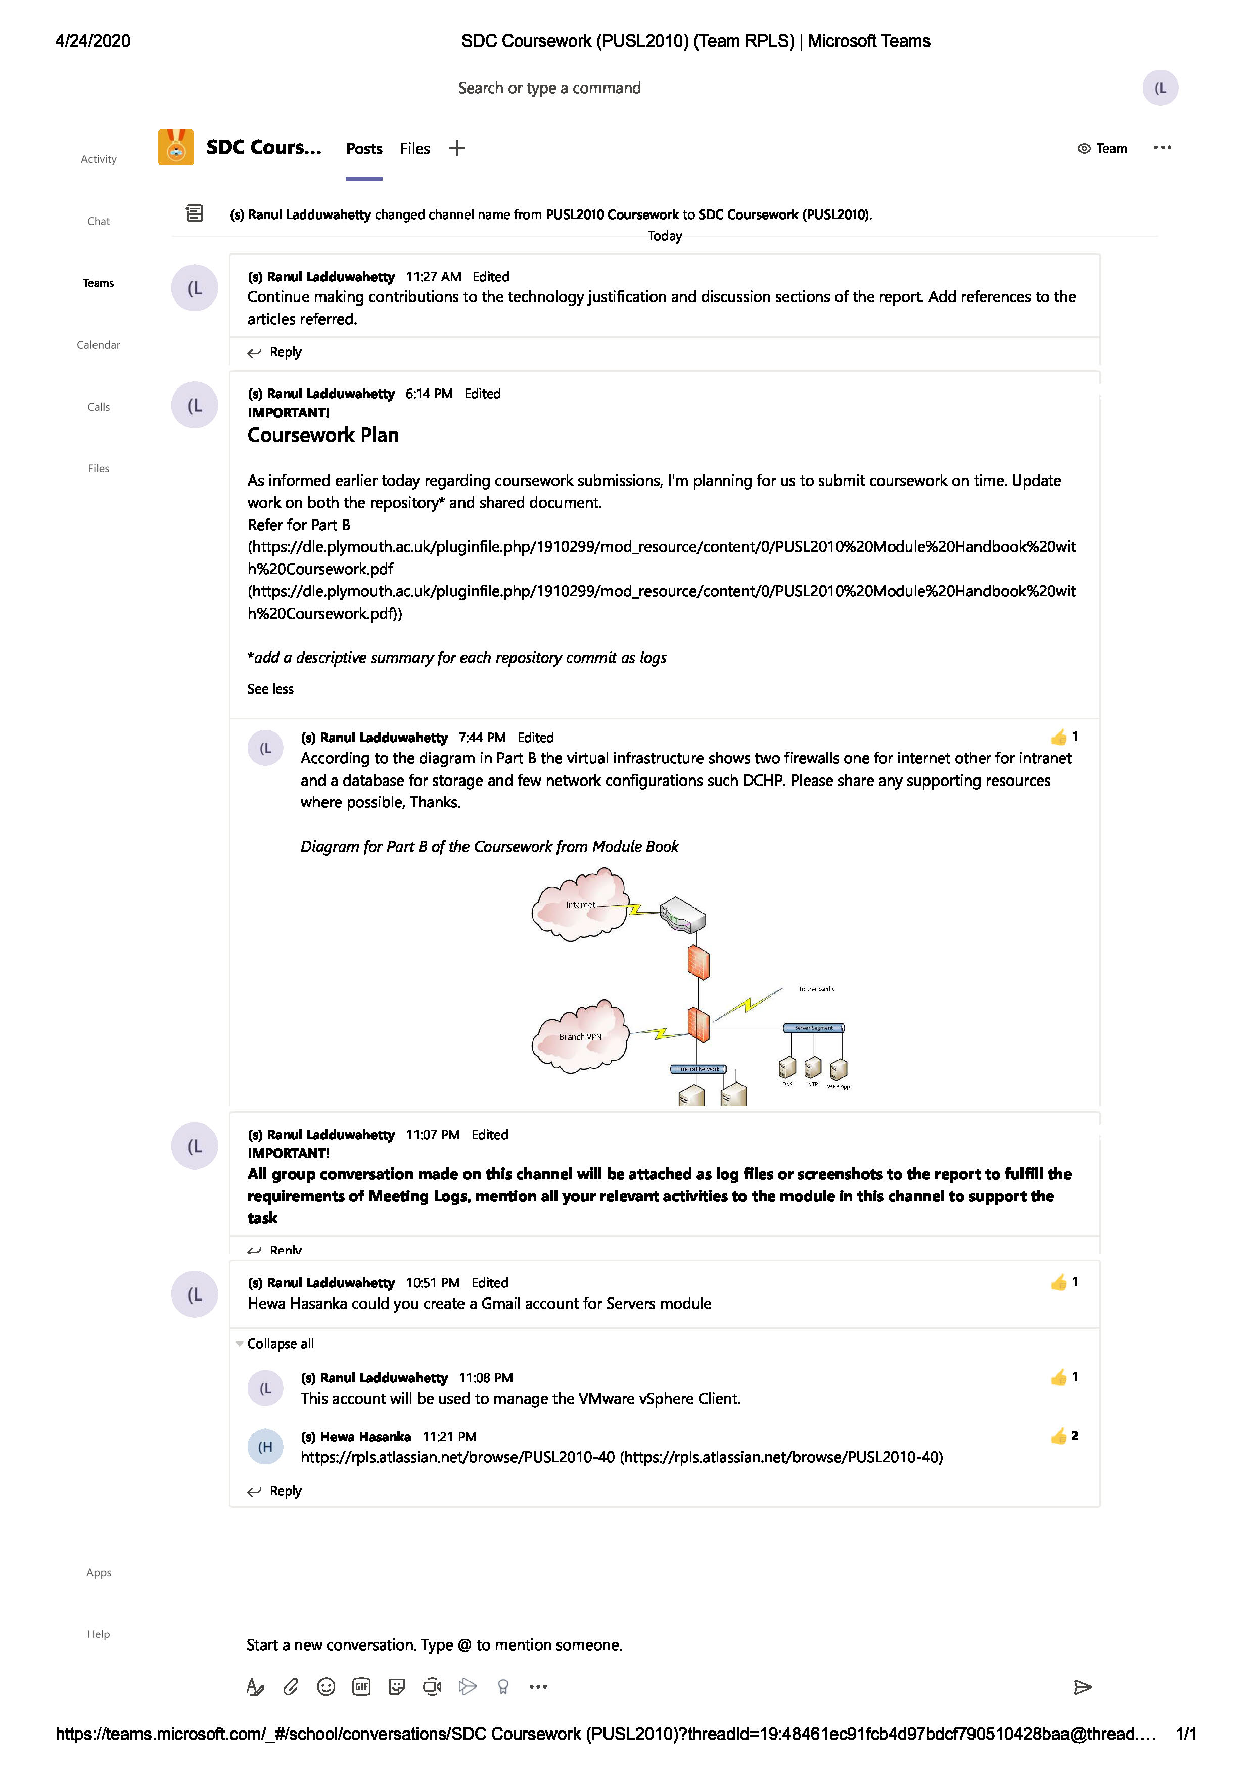

*Figure 37: Screenshot Chat Log from Microsoft Teams*

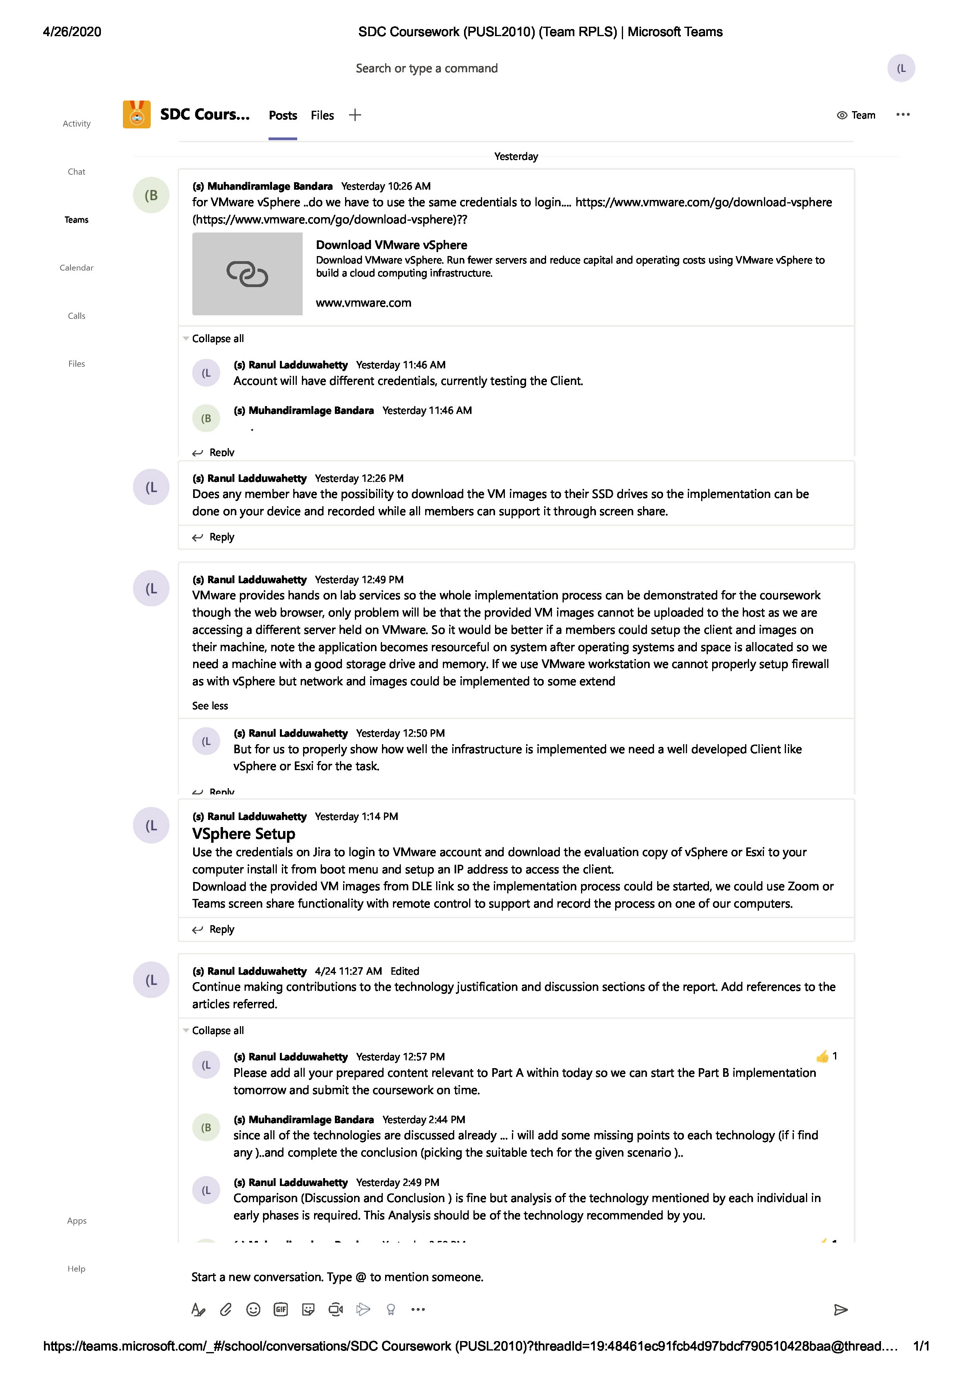

*Figure 38: Screenshot Chat Log from Microsoft Teams*

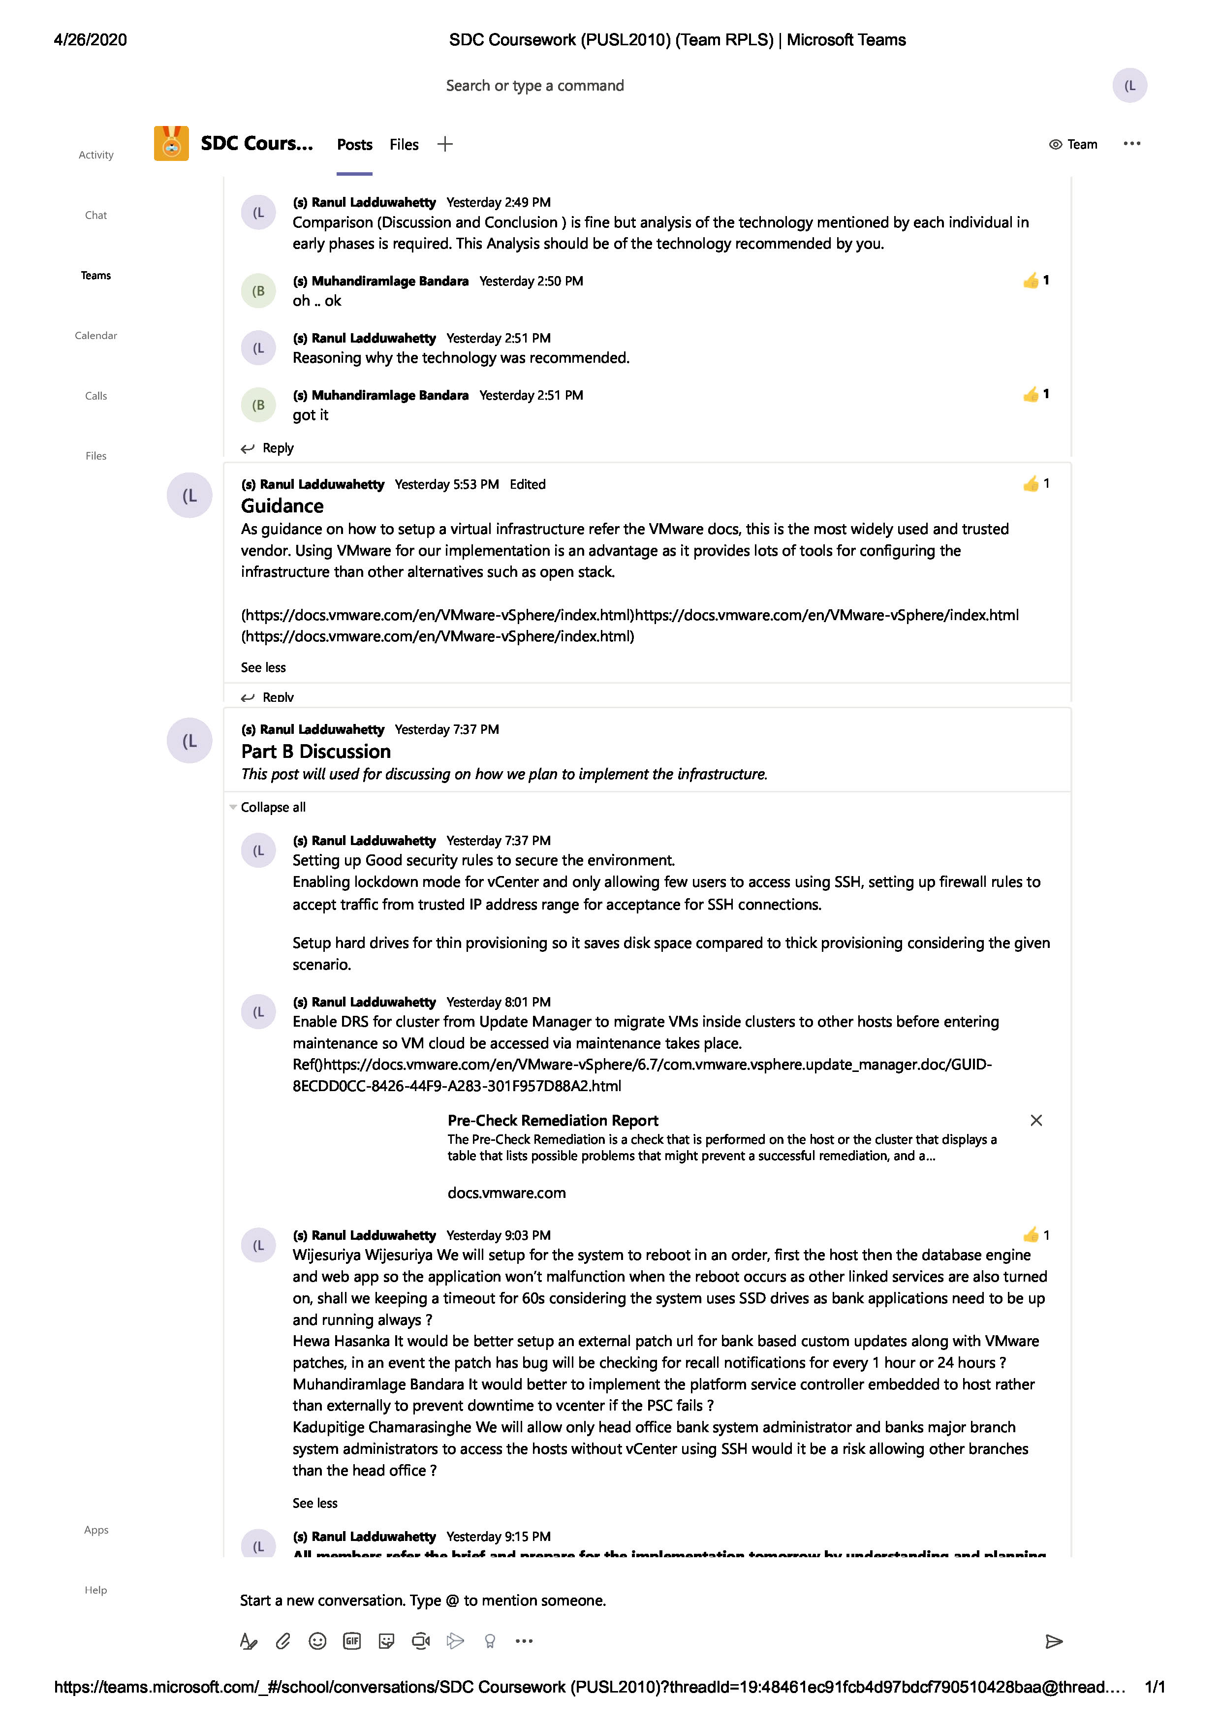

*Figure 39: Screenshot Chat Log from Microsoft Teams*

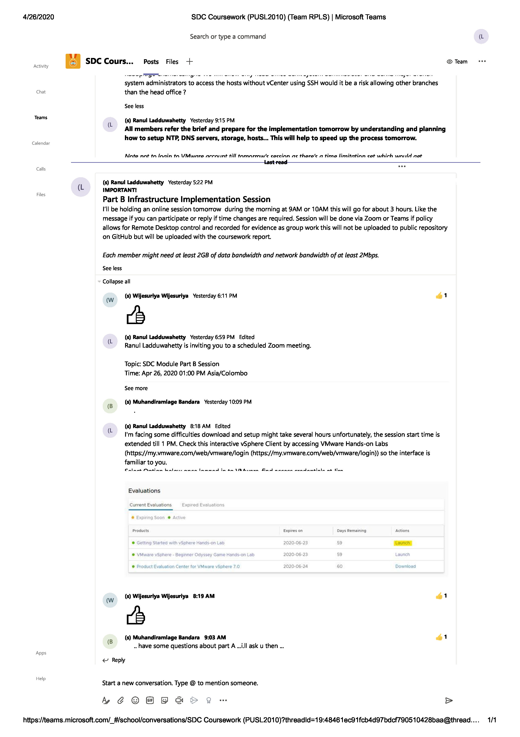

*Figure 40: Screenshot Chat Log from Microsoft Teams*

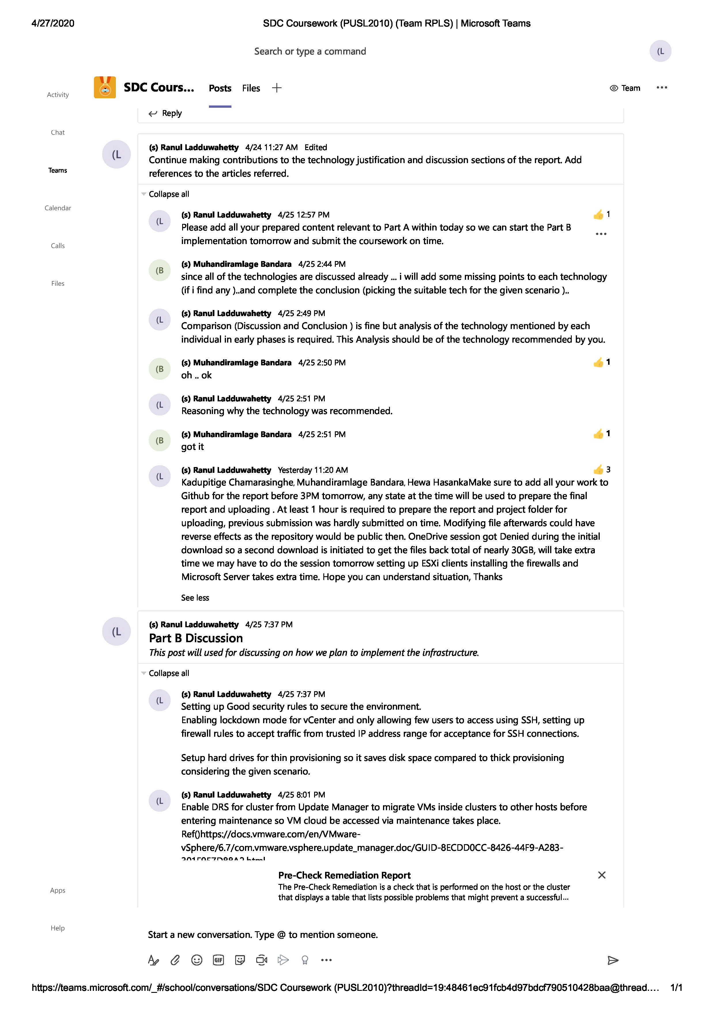

*Figure 41: Screenshot Chat Log from Microsoft Teams*

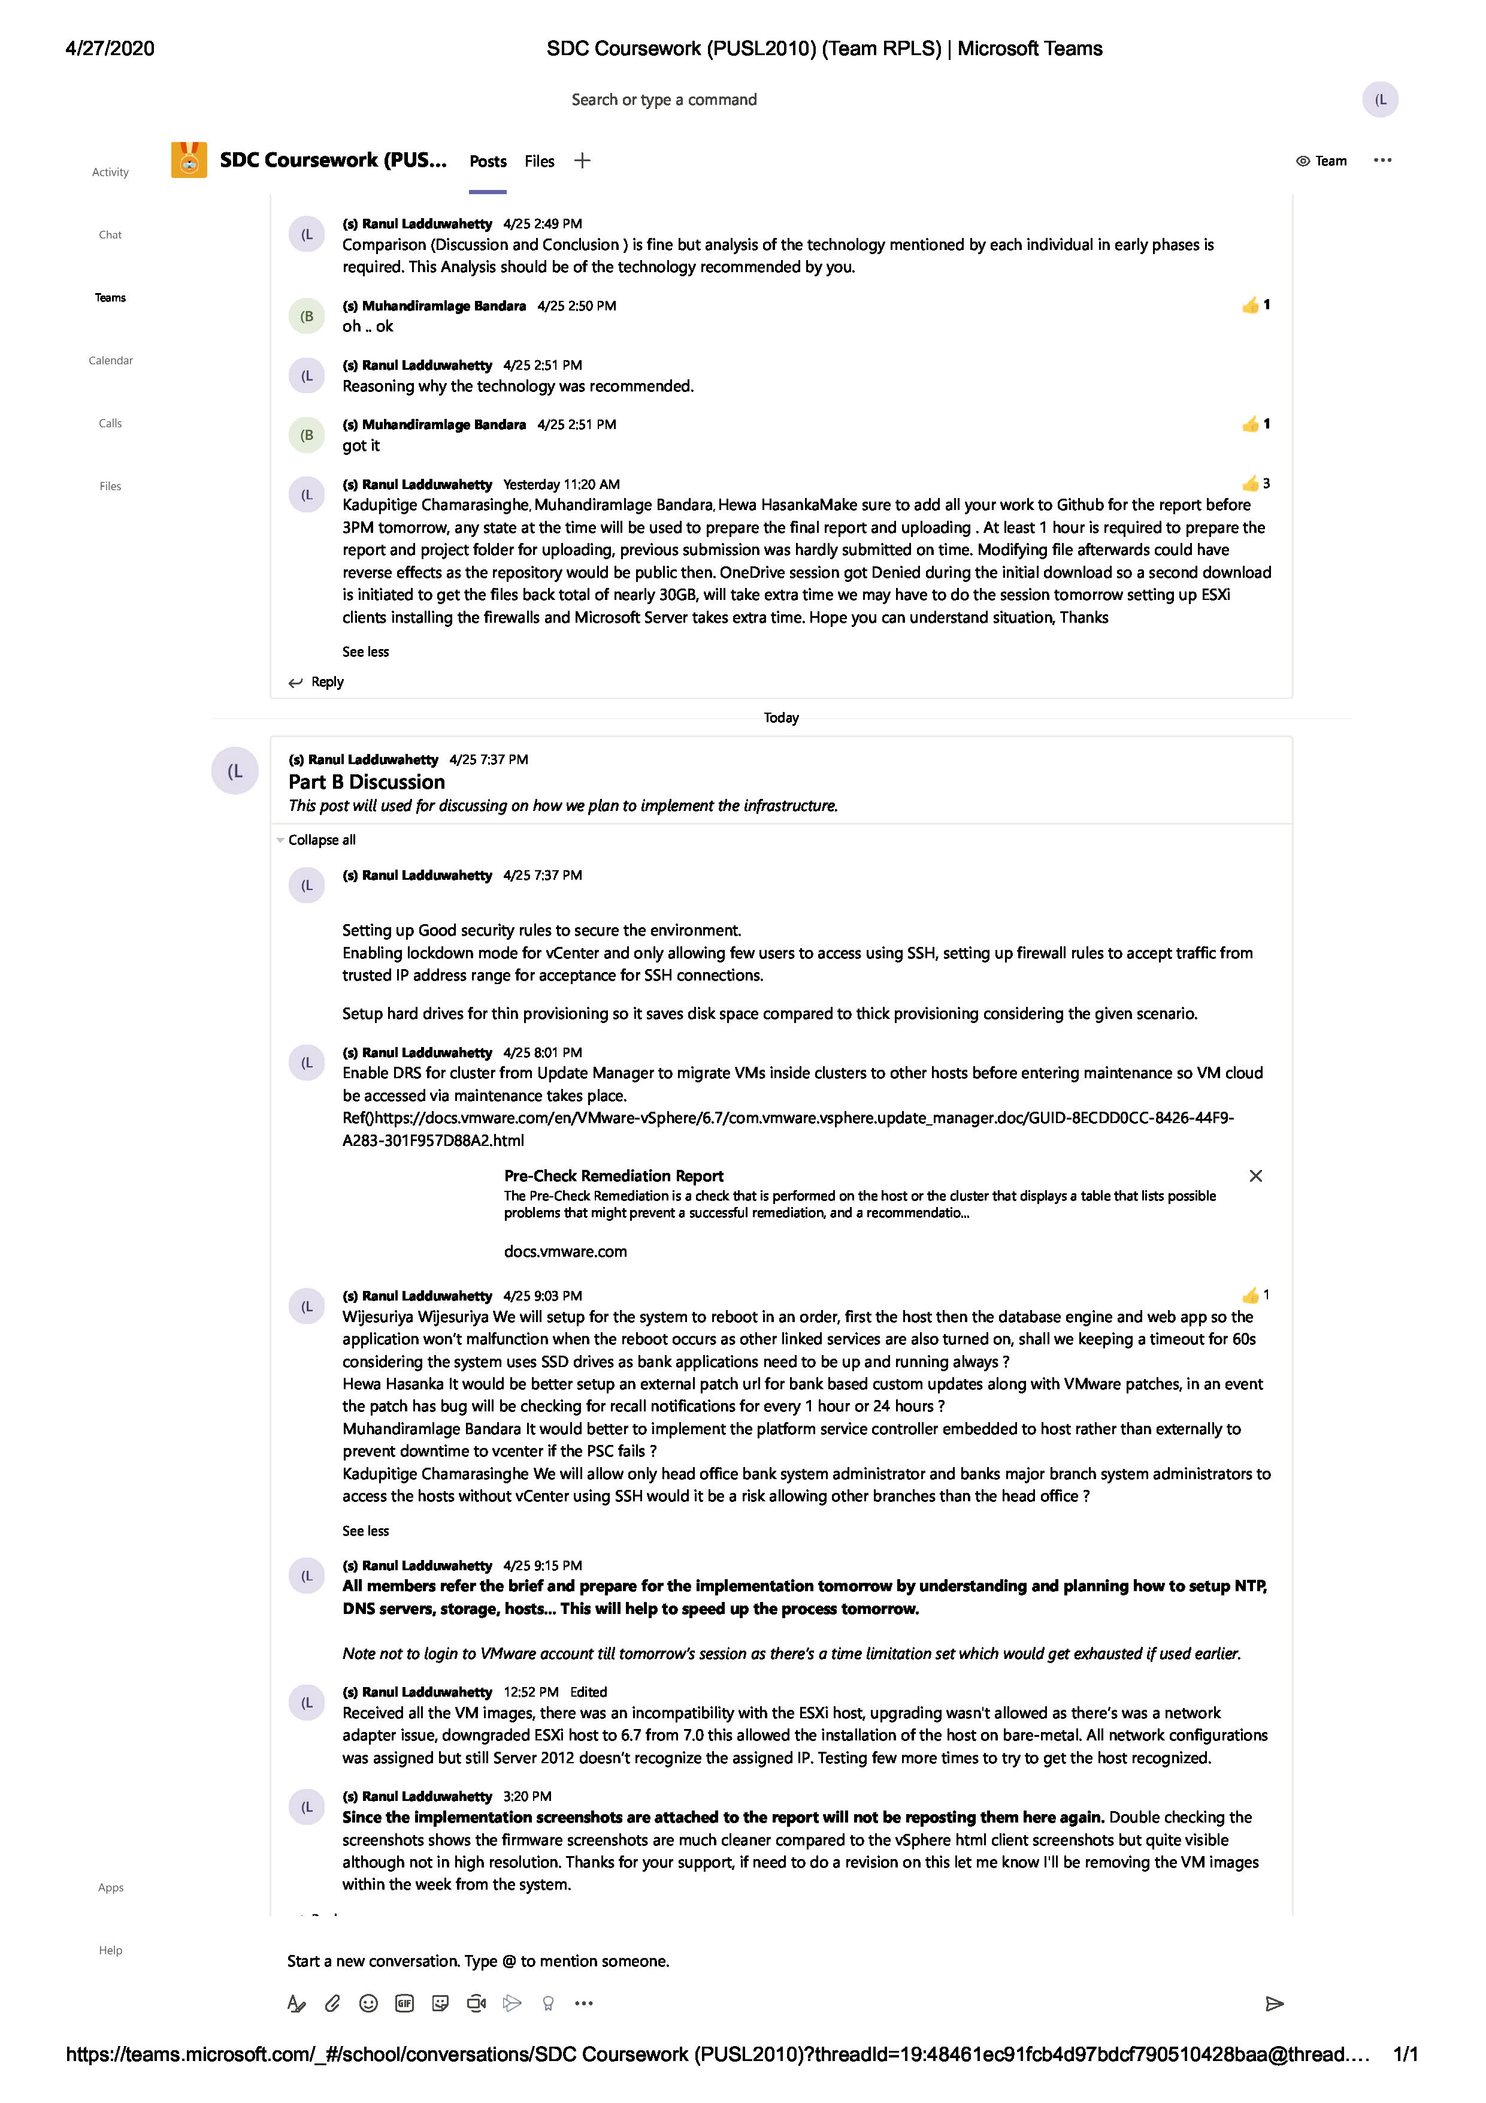

*Figure 42: Screenshot Chat Log from Microsoft Teams*

# WORKLOAD

|  |  |  |  |
| --- | --- | --- | --- |
| Student Name | Plymouth ID | Work Description* | Contribution as a % |
| Ranul Ladduwahetty | 10673986 | * Literature Review * Analysis * Technology Justification * Discussion and Conclusion * VM Setup and Implementation of Infrastructure for Part B Scenario | 100% |
| Nidula Wijesuriya | 10674049 | * Analysis * Technology Justification * Discussion and Conclusion * VM Setup and Implementation of Infrastructure for Part B Scenario | 100% |
| H.V.L. Hasanka | 10673969 | * Analysis * Technology Justification * Discussion and Conclusion * VM Setup and Implementation of Infrastructure for Part B Scenario | 100% |
| M.I.C BANDARA | 10673936 | * VM Setup and Implementation of Infrastructure for Part B Scenario * Analysis * Technology Justification * Discussion |  |
| Mr. K.M.R.P. CHAMARASINGHE | 10673943 | - | - |

*Each member signed and filled this workload form.

*For a contribution not filled in the matrix defines that the member was unable to support or was unreachable to group members, due to the Covid-19 condition at the time of assessment.

# BIBLIOGRAPHY

[Apostu, A. (2013) 'Study on advantages and disadvantages of Cloud Computing – the advantages of Telemetry Applications in the Cloud', Recent Advances in Applied Computer Science and Digital Services, Economic Informatics and Cybernetics Department Academy of Economic Studies 15-17, Calea DorobanŃi, Bucharest 4, University POLITEHNICA of Bucharest ROMANIA.](https://pdfs.semanticscholar.org/ada5/876e216130cdd7ad6e44539849049dd2de39.pdf)

Docs.vmware.com. 2020. *Configuring And Viewing Notifications*. [online] Available at: <https://docs.vmware.com/en/VMware-vSphere/6.7/com.vmware.vsphere.update_manager.doc/GUID-0454B3CD-F3EE-424D-AA5F-BEC433D38CFF.html> [Accessed 2 May 2020].

Docs.vmware.com. 2020. *Types Of Update Manager Notifications*. [online] Available at: <https://docs.vmware.com/en/VMware-vSphere/6.7/com.vmware.vsphere.update_manager.doc/GUID-AD4FA8A3-5FED-4F83-8262-EFF567DBC08C.html> [Accessed 2 May 2020].

# REFERENCES

AALPHA (2020) *saas users preference*. Available at: <https://www.aalpha.net/blog/how-to-develop-a-cloud-based-saas-application-software-product/attachment/saas-users-preference/> (Accessed: 02 April 2020).

FinancesOnline (2020) *62 SaaS Statistics You Must Learn: 2020 Market Share & Data Analysis*. Available at: <https://financesonline.com/saas-statistics/> (Accessed: 02 April 2020).

flexjobs (2020) *Remote Work Statistics: Shifting Norms and Expectations*. Available at: <https://www.flexjobs.com/blog/post/remote-work-statistics/> (Accessed: 03 April 2020).

Hou, T., 2020. *Iaas Vs Paas Vs Saas: What You Need To Know + Examples (2018)*. [online] The BigCommerce Blog. Available at: <https://www.bigcommerce.com/blog/saas-vs-paas-vs-iaas/#the-key-differences-between-on-premise-saas-paas-iaas> [Accessed 26 April 2020].

Ouellette, C., 2020. *Online Shopping Statistics You Need To Know In 2020*. [online] OptinMonster. Available at: <https://optinmonster.com/online-shopping-statistics/> [Accessed 5 April 2020].

Our World in Data (2017) *Internet*. Available at: <https://ourworldindata.org/internet> (Accessed: 08 April 2020).

PROS AND CONS OF SERVER VIRTUALIZATION (2016) *techgenix*. Available at: <http://techgenix.com/pros-cons-server-virtualization/> (Accessed: 09 April 2020).

Ranger, S., 2020. *What Is Cloud Computing? Everything You Need To Know About The Cloud, Explained | Zdnet*. [online] ZDNet. Available at: <https://www.zdnet.com/article/what-is-cloud-computing-everything-you-need-to-know-from-public-and-private-cloud-to-software-as-a/> [Accessed 26 April 2020].

Storage Craft Recover Zone (2020) Available at: <https://blog.storagecraft.com/cloud-vs-in-house-servers/> (Accessed 25 April 2020).

The Pros and Cons of Cloud vs in House Servers (2020) *SysGen*. Available at: <https://sysgen.ca/cloud-vs-in-house-servers/> (Accessed: 09 April 2020).